Name: ___________________________________________ # _______ Block: ______

Art Criticism

Notebook Check #1: Art Anticipation Guide
Take time to think about how much you agree or disagree with each statement below. Mark an X somewhere between “strongly agree” and “strongly disagree” on the line that reflects your thoughts.
- Art comes from around the world and from different time periods.
Strongly Disagree
Strongly Agree

- Art should tell a story or have an important meaning.

- Art is beautiful.

- Art is realistic.

- Art is for hanging on the wall.

- Art is made out of many different materials.

- Art can come in all different shapes and sizes.

- Anyone can make art

- If it is not intended for a museum, it is not art.

Choose two statements from the anticipation guide to expand on.
1. _________________________________________ because _______________________________________________________________________________________________________________________________________________________________________________________________________________________________________________________________________.
2. _________________________________________ because _______________________________________________________________________________________________________________________________________________________________________________________________________________________________________________________________________.

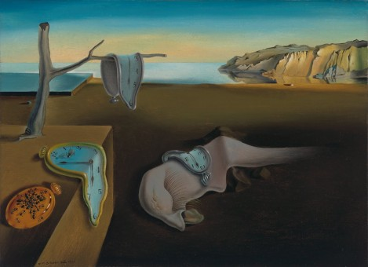
Notebook Check #2: Four Steps of Art Criticism Notes
View The Persistence of Memory by Salvador Dali. Continue your practice of identifying elements and principles in this work. List them, and then state what you found to be the most important, JUSTIFYING your answer with EVIDENCE from the text.
Elements and Principles:
_____________________________________________________
_____________________________________________________
_____________________________________________________
_____________________________________________________

Most Important and Justification:
______________________________________________________________________________________________________________________________________________________________________________________________________________________________________________________________________________

The Four Steps of Art Criticism:
- ________________________________
- ________________________________
- ________________________________
- ________________________________

Step One: Description
- Objectively describe the ___________________________ and physical _______________________________ of the artwork
- Do NOT ___________________________ or discuss the ________________________________ and principles of art at this ______________________________
Step Two: Analysis
- ________________________ the composition
- Use the elements and principles to guide your looking
- Elements of Art: Line, shape, ________________________________, texture, value, __________________________, and form
- Principles of Design: Rhythm, emphasis, ________________________________, movement, variety, ________________________________, proportion, and balance
Step Three: Interpretation
- What does the artwork _______________________? What is the artist trying to ___________?
- Describe the ___________________, meaning, _______________, idea, mood, and/or feelings in the artwork.
- Historical and art _____________________ relationships
- _____________________ backed up by ___________________ from the artwork
Step Four: Evaluation
- Your ____________________ about the artwork
- What is __________________ or ___________________ in the work?
- What is the artwork’s _________________________?
- _________________________ supported by evidence in the artwork.
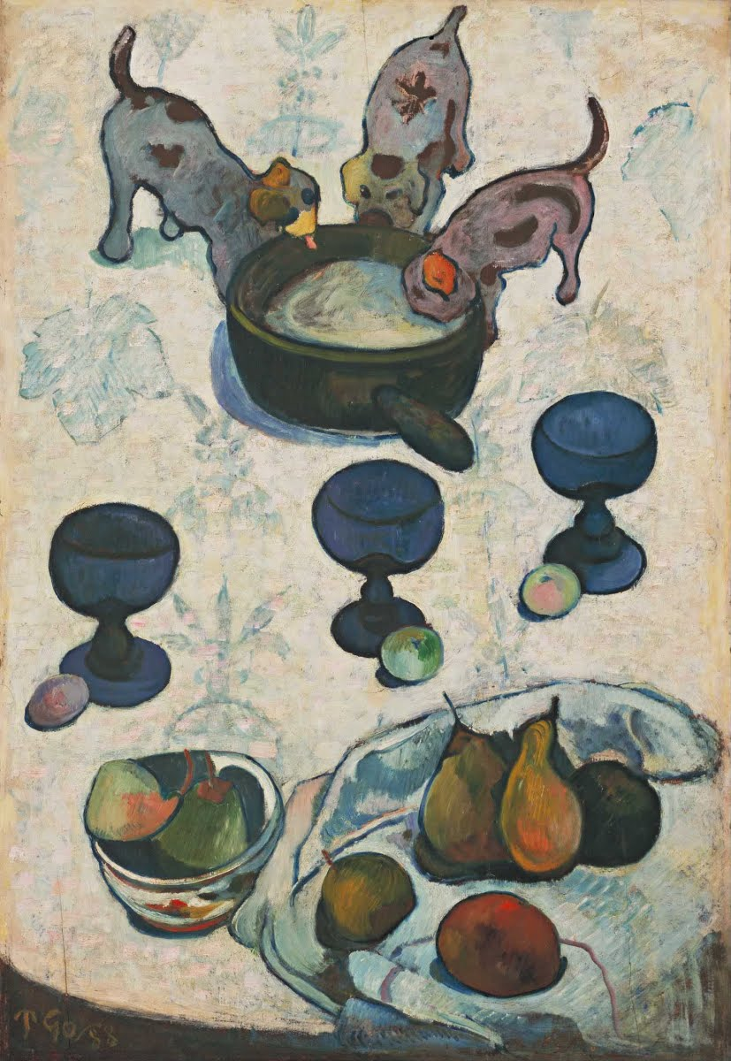
Notebook Check #3: Art Criticism Quiz
Look at the artwork on the slide, determine which step of art criticism it falls in, and label each statement below with the following letters:

D -- Description
A -- Analysis
I -- Interpretation
E -- Evaluation

Still Life with Puppies by Paul Gauguin

____ This looks like it was painted by an artist in the late 1800s or early 1900s because of the style and
flatness. I think the artist wanted to paint a pleasing composition using items from everyday life.

____ There are 3 puppies drinking out of a pan or bowl.
____ The objects in the painting seem to stand out against the light background because the values are
so much darker.

____ This is adorable! I would hang this piece on my wall.
____ Three blue goblets are beside 3 round fruits. More fruit is arranged on a cloth next to a bowl
containing a pear.

____ The artist loves dogs.

Notebook Check #4: Art Criticism Practice

Work of Art: ______________________________________ Artist: ________________________________

DESCRIPTION:  - Objectively describe the contents and physical characteristics of the artwork  - Do not interpret or discuss the elements and principles of art at this stage | ANALYSIS:  - Analyze the composition, use the elements and principles to guide your looking  - Elements of Art: Line, Shape, Color, Texture, Value, Space, Form Principles of Design: Rhythm, Emphasis, Unity, Movement, Variety, Pattern, Proportion, Balance
Interpretation:  - What does the artwork mean? What is the artist trying to say?  - Describe the story, meaning, message, idea, mood, and/or feelings in the artwork.  - Historical and art historical relationships  - Opinions backed up by evidence from the artwork. | EVALUATION:  - Your judgment about the artwork  - What is effective or ineffective in the work?  - What is the artwork’s value?  - Opinion supported by evidence in the artwork.
Notebook Check #5: Art Criticism Practice

Work of Art: ______________________________________ Artist: ________________________________

DESCRIPTION:  - Objectively describe the contents and physical characteristics of the artwork  - Do not interpret or discuss the elements and principles of art at this stage | ANALYSIS:  - Analyze the composition, use the elements and principles to guide your looking  - Elements of Art: Line, Shape, Color, Texture, Value, Space, Form Principles of Design: Rhythm, Emphasis, Unity, Movement, Variety, Pattern, Proportion, Balance
Interpretation:  - What does the artwork mean? What is the artist trying to say?  - Describe the story, meaning, message, idea, mood, and/or feelings in the artwork.  - Historical and art historical relationships  - Opinions backed up by evidence from the artwork. | EVALUATION:  - Your judgment about the artwork  - What is effective or ineffective in the work?  - What is the artwork’s value?  - Opinion supported by evidence in the artwork.
Notebook Check #6: Art Criticism Practice

Work of Art: ______________________________________ Artist: ________________________________

DESCRIPTION:  - Objectively describe the contents and physical characteristics of the artwork  - Do not interpret or discuss the elements and principles of art at this stage | ANALYSIS:  - Analyze the composition, use the elements and principles to guide your looking  - Elements of Art: Line, Shape, Color, Texture, Value, Space, Form Principles of Design: Rhythm, Emphasis, Unity, Movement, Variety, Pattern, Proportion, Balance
Interpretation:  - What does the artwork mean? What is the artist trying to say?  - Describe the story, meaning, message, idea, mood, and/or feelings in the artwork.  - Historical and art historical relationships  - Opinions backed up by evidence from the artwork. | EVALUATION:  - Your judgment about the artwork  - What is effective or ineffective in the work?  - What is the artwork’s value?  - Opinion supported by evidence in the artwork.
Notebook Check #7: Source Sleuth
Evaluating Internet Source
Who is the suspect?
AUTHOR
- Credible sources _________________ list the author
  - Is the author’s _________ listed? If not, you may want to __________________ your source
  - If not author is listed, is the article associated with an _______________ or ___________________?
- Credible authors typically list _____________ (qualifications for being able to write about particular _____________). These should be RELEVANT!
  - If your author is a ______________, he probably is not qualified to write about the influence of censorship on early Byzantine art.
- Personal __________are NOT reliable sources for _____________ and should NOT be used...
  - On that note NEITHER IS _________________

THINK PAIR SHARE
Why do you think an author’s credibility is important when looking for information?
________________________________________________________________________________________________________________________________________________________________

Does he look like a good guy?
APPEARANCE
- Is it the kind of __________ you'd be comfortable _____________ with others?
- Are there __________ and __________ errors?
- Is the content easy to read and understand?
- When was he born?
  - More _____________ websites will provide readers with up-to-date content.
  - If you are looking for information about a ____________ topic, web addresses should be current.

THINK PAIR SHARE
Why might spelling and grammar errors be an indication that a website is not reliable?
____________________________________________________________________________________________________________________________________________

What’s the suspect’s home situation?
HOME PAGE
- Check out the __________ __________of your article. What does it look like?
  - Information on a home page should be easy to __________ and _________
  - Any links should be _____________
  - Look for an "About Us" section which could _____________ an author or _______________

Can he be trusted?
RELIABILITY
- _______________ websites will share where they found their ____________ (called _____________, sources, or works cited)
- Check the _____________ the website for sources
  - If a website lists _____________ among its sources, the information could be ______________!
- FOLLOW THE CLUES!
  - A works cited page is an excellent source for more __________________

What’s in a name?
DOMAIN NAME
- Lots of useful information can be found in the ___________ name. Check out the website's ________________ for these clues.
  - .org - an ____________ site, such as a not-for-profit _________________
  - .com - a ________________ or commercial site
  - .net - a site from a network _____________ or an ______________ service provider
  - .edu - a site affiliated with a higher _______________ institution
  - .gov - a federal _________________ site

THINK PAIR SHARE
Which of the the above mentioned domain names do you think would be the most reliable? Why?
________________________________________________________________________________________________________________________________________________________________

NOTEBOOK CHECK #8 & 9: Artist Research Project
You will be conducting a group research project with your group. You will be allowed to select your own artist. You will cite ALL sources that you use and critique a work of art by your selected artist.
Artist:
Biographical Info:
- Place/date of birth:

- Place/date of death:

- Primary type of artwork (ex: painting? Drawing? Sculpture? Printmaking? Ceramics)

- Media (see your handbook for a definition):

- Write a short summary of your artist’s life and history.

- What are/were the major influences of your selected artists? (Parental artists? Gloomy childhood? Love? The struggles of the period? HINT: search through your artist’s biography...see what you can find.)

- Style or period of art? What are the dates of this period?

- What are the characteristics of the period in which the artist worked?

- What are the characteristics of this particular artist? What makes him/her unique?

- Interesting/Personal information on the artist:

- Three other artists who work in this style (from the time period of the artist - or contemporary artists working in this same style). How is the work similar? How is the work different?

- Quote by your artist:

- Which work of art by your selected artist do you admire most? WHY?

This is extra space in case you want to copy down all of the links you use (NOT A WORKS CITED) in order to create your works cited page… or even think of this page as your ROUGH draft for your works cited page. This page is also good for recording any additional notes in case you ran out of room on another page. This would also be a good place to figure out and record who will present the information for your project.

Select FIVE works by your selected artist and fill in the information below about each work.
Title:
Date: Media: Size:
Location (museum/collection):
Short Description:
Title:
Date: Media: Size:
Location (museum/collection):
Short Description:
Title:
Date: Media: Size:
Location (museum/collection):
Short Description:
Title:
Date: Media: Size:
Location (museum/collection):
Short Description:
Title:
Date: Media: Size:
Location (museum/collection):
Short Description:
Notebook Check #10: Works Cited Page

