Name: _____________________________________________________#_____ Block________

Article of the week #3

“The Value and Importance of the Arts and the Humanities in Education and Life”
By Barbara Ernst Prey 09/09/2014
http://www.huffingtonpost.com/barbara-ernst-prey/the-value-and-importance-_b_5788116.html

Read and annotate the following article. Answer the questions that follow.

- A number of my summer conversations have centered around the importance of the arts and the humanities. I spoke with my friend Dr. Mitchell B. Reiss, the President of Washington College, about the humanities and arts as an essential part of a college curriculum. He was the President’s Special Envoy to the Northern Ireland Peace Process from 2003-2007, when we made historic progress towards ending the “Troubles” and realizing the promise of the Good Friday Agreement as well as Director of the Office of Policy Planning for Secretary Colin L. Powell, from 2003-2005. He will become the President and CEO of The Colonial Williamsburg Foundation later this fall.
- Why are you a strong advocate for the arts?
Most of us consider the arts to include the literary arts: fiction, creative nonfiction, essays and poetry; the performing arts, such as dance, theater and film; and the visual arts, which include painting, sculpture, mixed media and installation art. The arts encompass a broader spectrum of our lives.
- At Washington College, we believe the education we provide our students is far more than just career prep for their first job. We challenge our students to develop life-long skills such as analytical thinking, clarity in written and spoken expression, collaboration, and creativity. These skills can all be developed through the arts and are valuable in any career.
- Just as importantly, we believe that our mission is to help students prepare for a rich, meaningful and engaged life that goes well beyond job titles and salary levels. Exposure to and understanding of the arts is key to developing qualities of responsible citizenship.

- Would you elaborate?
A lot of what artists do is tell stories. They help us make sense of our world, and they broaden our experience and understanding. The arts enable us to imagine the unimaginable, and to connect us to the past, the present, and the future, sometimes simultaneously.

- Great literature, films and visual art transport us to different places and cultures; great art even allows us to see ourselves and our own community through a different lens. To see King Lear performed on stage helps us confront our own complicated family dynamics. Likewise, if we study the faces captured in Dorothea Lange’s black and white portraits from the 1930s and 1940s, we can better empathize with those who endured the Dust Bowl and the Great Depression.
- I’ve heard biographer and journalist Walter Isaacson say that science can give us empirical facts and try to tie them together with theories, but it’s the humanists and the artists who turn them into narratives with moral, emotional and spiritual meanings. He’s right, of course. Art gives meaning to the data science provides.
- As a former diplomat, Ambassador and professor of international relations, I agree with Cornell University president David Skorton that, “our nation’s future may depend on our creativity and our ability to understand and appreciate the cultures around the world as much as on our proficiency in reading and math.”

- What are your thoughts on STEM (Science-Technology-Engineering-Math) vs. STEAM (inserting the Arts)?
We need both. And ideally, we need STEM grads who have integrated the arts into their scientific studies and artists who understand the sciences. This is one reason why we are promoting greater interdisciplinary and multidisciplinary teaching and learning; it is a complex world and we need to understand the interconnections between and among science, the arts and humanities.
- For example, Steve Jobs loved to talk about the intersection of technology and the humanities, which include the arts. In 2010, while introducing the iPad, he said “It’s in Apple’s DNA that technology alone is not enough. It’s technology married with liberal arts, married with the humanities, that yields the results that make our hearts sing.”
- Throughout history, our greatest inventors and scientists have merged scientific knowledge and discovery with artistic creativity. For example Albert Einstein studied piano and violin as a child and, when he was an adult, music helped him think things through. When he was having trouble with a scientific theory, he would strike a few chords on the piano or pick up the violin and play, and that would often free up a constructive thought or solution. He stressed the importance of the creative mind, once saying, “I’m enough of an artist to draw freely on my imagination, which I think is more important than knowledge. Knowledge is limited. Imagination encircles the world.”

- I was fortunate to have a mother who was Head of the Design Department at Pratt Art Institute in New York City and a great artist herself, so I grew up appreciating the importance of creativity and imagination. As a member appointed by the President of the United States to the National Council on the Arts, the Advisory Board to the National Endowment for the Arts, I am a strong advocate for the arts. As a college President what would you tell parents who might not share this view?
Companies and organizations that want to stay globally competitive realize they need employees who are multi-disciplinary, creative thinkers able collaborate with other team members. Those qualities are at the heart of staging a play or performing in a jazz quartet. Like the liberal arts in general, training in the arts improves our ability to pull together and synthesize seemingly disparate ideas and information into a coherent and meaningful whole. Further, taking a studio art course or studying art history helps build an aesthetic sensibility that can influence other areas of thinking. The Conference Board, an independent association that provides its members with business and economic research, has reported that creativity is among the top five applied skills sought by business leaders
Beyond that, your resume and job interview will reflect a broader understanding of what it means to be cultured and cosmopolitan; really, what it means to be fully human. Every business needs people who understand the big picture and who can communicate effectively about its mission and values.

- Anything else you would like to mention?
I consider myself one of the least artistically talented people on the planet, but I love the arts! Even those of us who can’t put oil to canvas, hold a note or write a sonnet can appreciate and learn from the artist’s interpretation of the human experience. At their best, the arts strike a universal chord that suggests that we are not alone in our experience of joy, or grief, or courage. Studying the arts in college prepares the person for a lifetime of pleasure and appreciation, of being open to new experiences and of becoming that ideal every liberal arts college strives to produce—a life-long learner.
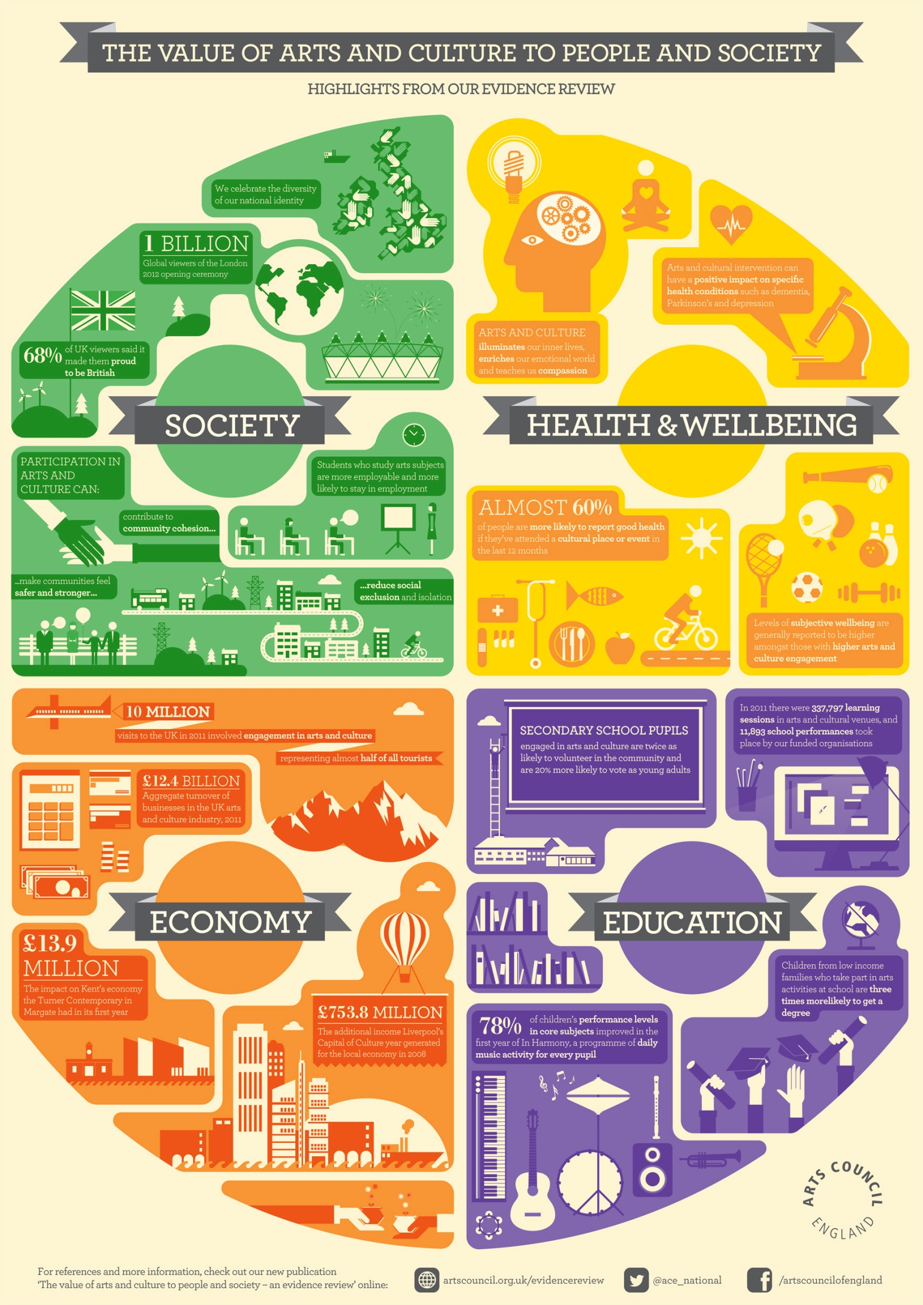

Answer the following questions in complete, thorough sentences. Be sure to TAG and ICE! Use the ACTIVE READING STRATEGY.
Paraphrase the following quote:“I’m enough of an artist to draw freely on my imagination, which I think is more important than knowledge. Knowledge is limited. Imagination encircles the world.”

How does the infographic support the information located in the article?

Does art prepare us for life outside of the classroom? Explain using evidence from the text{Be sure to use your ICE and TAG format}

In the sixth paragraph of the article, what does the use of the phrase ‘responsible citizenship’ mean?

Find the word spectrum in the 2nd paragraph and, using context clues, determine a definition. AFTER you have written your own definition, look up the actual definition of the word and write it down. Is your definition similar to the original? How do they differ?

Create an MLA citation for this article.

