KEY  First and Last Name |  |  | Block
Early Christian and Byzantine Art
Points | Activity | Pages
 | - Vocabulary | 2
 | - Early Christianity | 3
 | - Christian Symbolism | 4
 | - Bumper Sticker Project | 5
 | - The Byzantine Empire | 6
 | - Byzantine Architecture | 7
 | - Byzantine Art | 8
 | - Byzantine Style | 9-10
 | - Discussion Questions | 11
 | - Study Guide | 12
100  _ | - Score

Vocabulary
Directions: Use the word bank to fill in the correct term to its definition
symbolism |  | disguise |  |  | treason | divine | persecution
 |  |  |  | to create a different appearance in order to conceal one's identity.
 |  |  |  | of, from, or like God.
 |  |  |  | hostility and oppressive treatment, especially because of political or religious beliefs.
 |  |  |  | the use of symbols to represent ideas or qualities.
 |  |  |  | the crime of betraying one's country
Directions: After the note-taking guide is complete, find and write the definitions to the following nouns.
 | Catacombs |  | 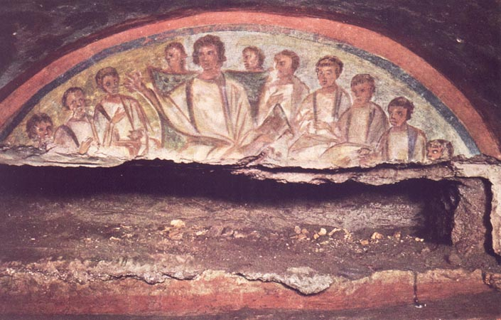
 | Fresco
 | Basilica
 | Pendentive |  | 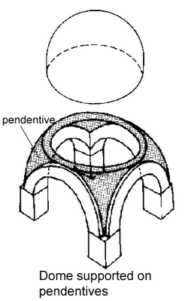  A three-sided, curved section of vaulting between the rim of a dome and each adjacent pair of the arches that support it.
 | mosaic |  | 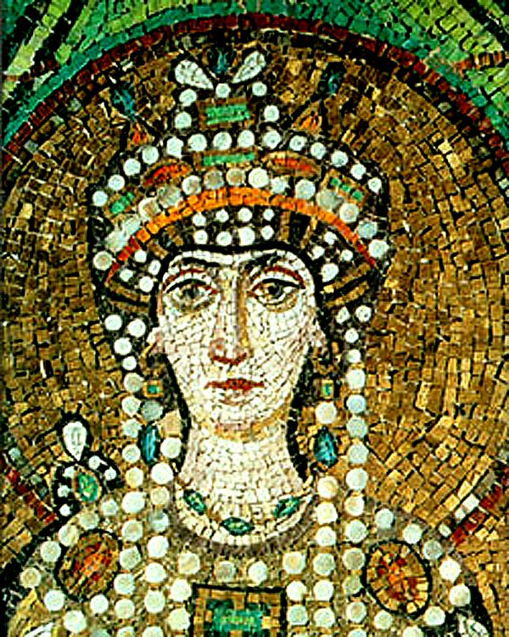
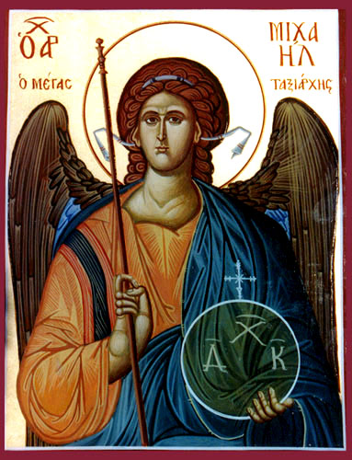
icon
 | iconostasis |  | 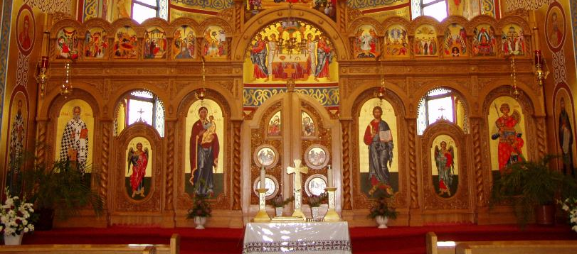

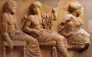
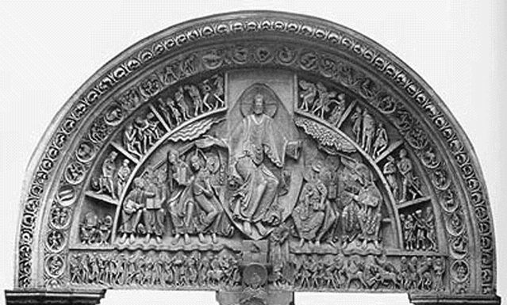
Early Christianity
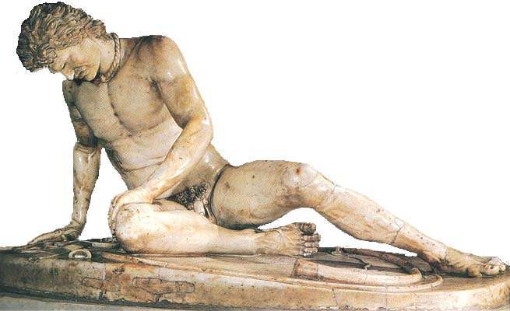
- Greeks and especially Romans produced art that was very __________________
Remember the beauty of the Greek and Roman sculpture
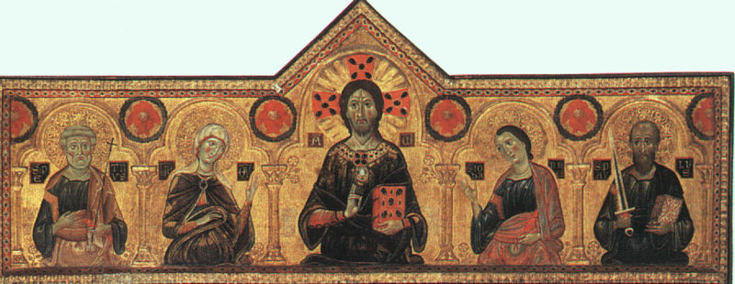
- Whereas, Early Christian and Byzantine art was more concerned with
  - __________________________________________________________
- Early Christianity
  - Christianity began in the ___________________________________________ as a Jewish sect but quickly spread throughout the _______________________________________ world.
  - Although it was originally ___________________________________ under the Roman Empire, it would ultimately become the __________________________________________________________.
  - For 250 years _________________________________ suffered from sporadic persecutions for their __________________________________ to worship the Roman emperor, considered _________________________________ and punishable by _________________________________.
    - Some felt, they needed some place to meet _____________________________________.
  - Catacombs
    - The Catacombs are ancient underground _____________________________, used by the Christian and the Jewish communities, throughout Rome.
    - Christians started using these underground burial tunnels to _______________________ _______________and to ______________________________________________________________________.
    - Christians did not want to ______________________________________________________________ (as done by the Romans) due to their belief in ________________________________________________.
The Cambrai Madonna  Early Christian or Greco- Roman? | 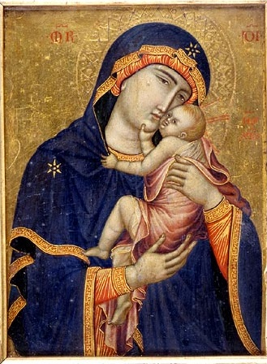 |  | Aphrodite of Cnidus  Early Christian or Greco- Roman?
Compare and Contrast: How did Early Christian art differ from the ancient Greco-Roman art?

Christian Symbolism
  - Unable to profess their faith _____________, the Christians made use of __________________, which they depicted on the walls of the ___________________________ and carved them on the marble-slabs which sealed the tombs
    - ____________________ - A method of ________________________ on plaster. Pigments are applied to thin layers of wet plaster so that they will be absorbed and the painting becomes part of the wall.
    - Early Christian art was created to ___________________________________________________________.
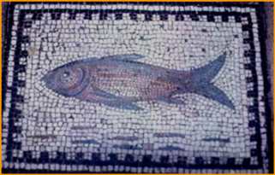
        - _________________________ (religious) content was the aim rather than depicting ______________________. It was a way to __________________________ the teachings of their faith from the __________________________________________________.
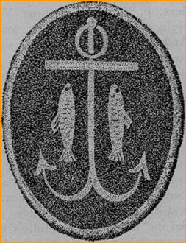
      - ________________: A common symbol was the fish. Sometimes it depicts men who have been ______________________ by Christ and his apostles.
      - _____________________: A common symbol in the catacombs is a boat anchor. It expresses the firm expectation of ____________________________________. The anchor was also used as a disguised __________________ in a day when the cross itself was seldom used for ______________________________________________________________________.
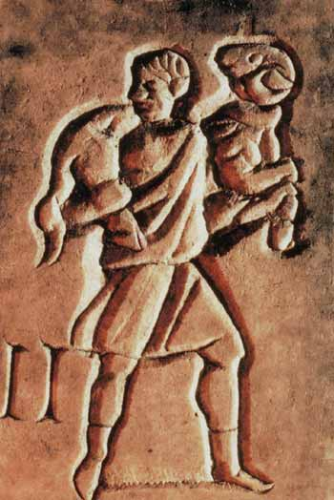
      - __________________________________________ with a lamb or goat around his shoulders represents _____________________________________________________ which He has saved. This symbol is often found in frescoes and relief sculptures. Also a symbol of Christ and his apostles and _______________________________________________________.
  - Funeral Art
    - ___________________________________ was carved with ____________________________________________ that advanced the Christian belief of the ____________________________________________________________________ because of _______________________________________________________. As time passed, the realistic figure proportions & the skill of the sculpting of Roman times deteriorated.
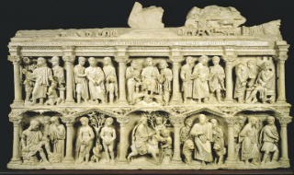
        - ___________________________________ became more ______________________________ than _______________________________________________________.
Bumper Sticker Project

This is a hypothetical situation…. Your school has banned your favorite sport or club!!! You and other members of your group decide to continue the sport or club in secret. Create a bumper sticker that would let other members of the sport or club know that you are a member but make it sneaky enough to mislead anyone who might report you for being in a forbidden sport or club.
- Group members must agree on one sport or club to be banned.
- Each group member must create an original symbol for the bumper sticker.
  - Each member must create a scratch of his or her symbol.
    - The draft should be drawn in the box below.
  - Each member should write a summary that explains why he or she chose the symbol and what the symbol represents.
- The group must come up with a slogan to put on the bumper sticker.
  - The slogan must relate to the banned club or sport but still be ambiguous enough to fool people who are not a part of the group.
Slogan:

Write a summary explaining why you chose this symbol and describing what the symbol represents: | Draw your symbol:

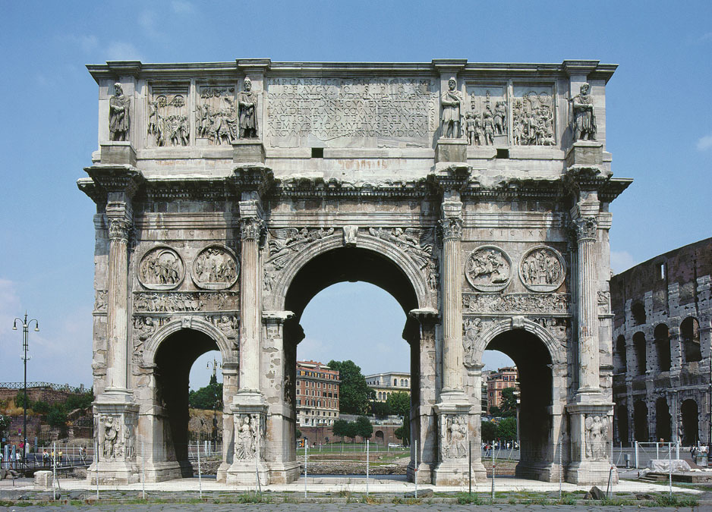
The Byzantine Empire

  - Constantine
    - In __________________, in a dream the night before an important battle, Constantine claimed he had a sign from the God of the _____________________________. Constantine won this battle and thereafter, showed his gratitude to the Christian God by ________________________________________ their religion thus ________________________ the _____________________________________________________________________________________________.
      - Constantine was the first Roman ruler to become a ______________________________ of the Christian religion.
      - This new freedom of worship helped _________________________ Christianity into many regions of Europe.
      - Around 315 A.D. the ____________________________ was built in Rome.
  - Byzantine Empire
    - After the death of Constantine in 337, the Roman Empire was split into Eastern and Western Empires.
    - The ___________________________ half (capital – _______________) ___________________________.
    - The ___________________________ half (_______________________ Empire), with its capital in Constantinople (ancient city of Byzantium), _________________________________________.
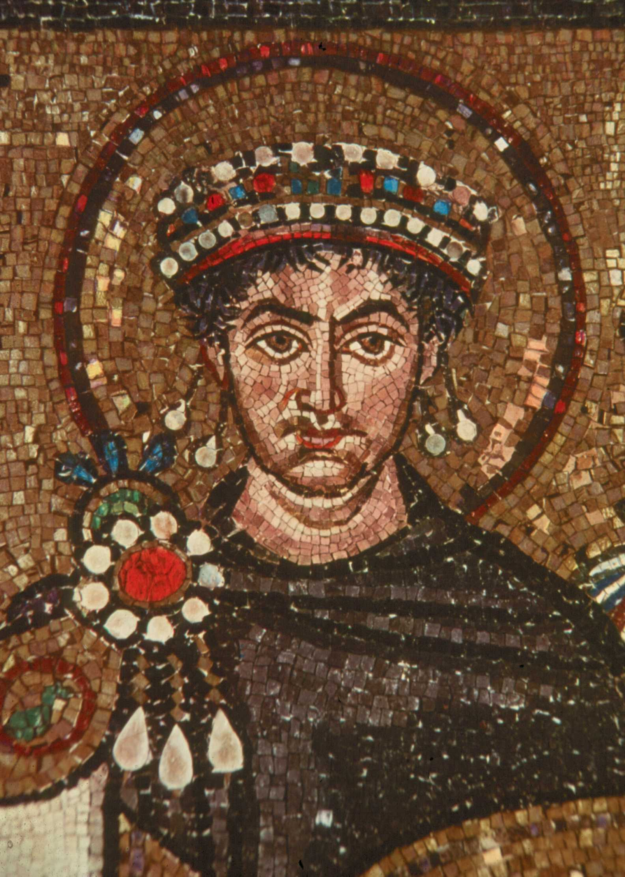
    - From there a succession of emperors (primarily ______________________________) ruled the Byzantine Empire as the Roman Empire dissolved.
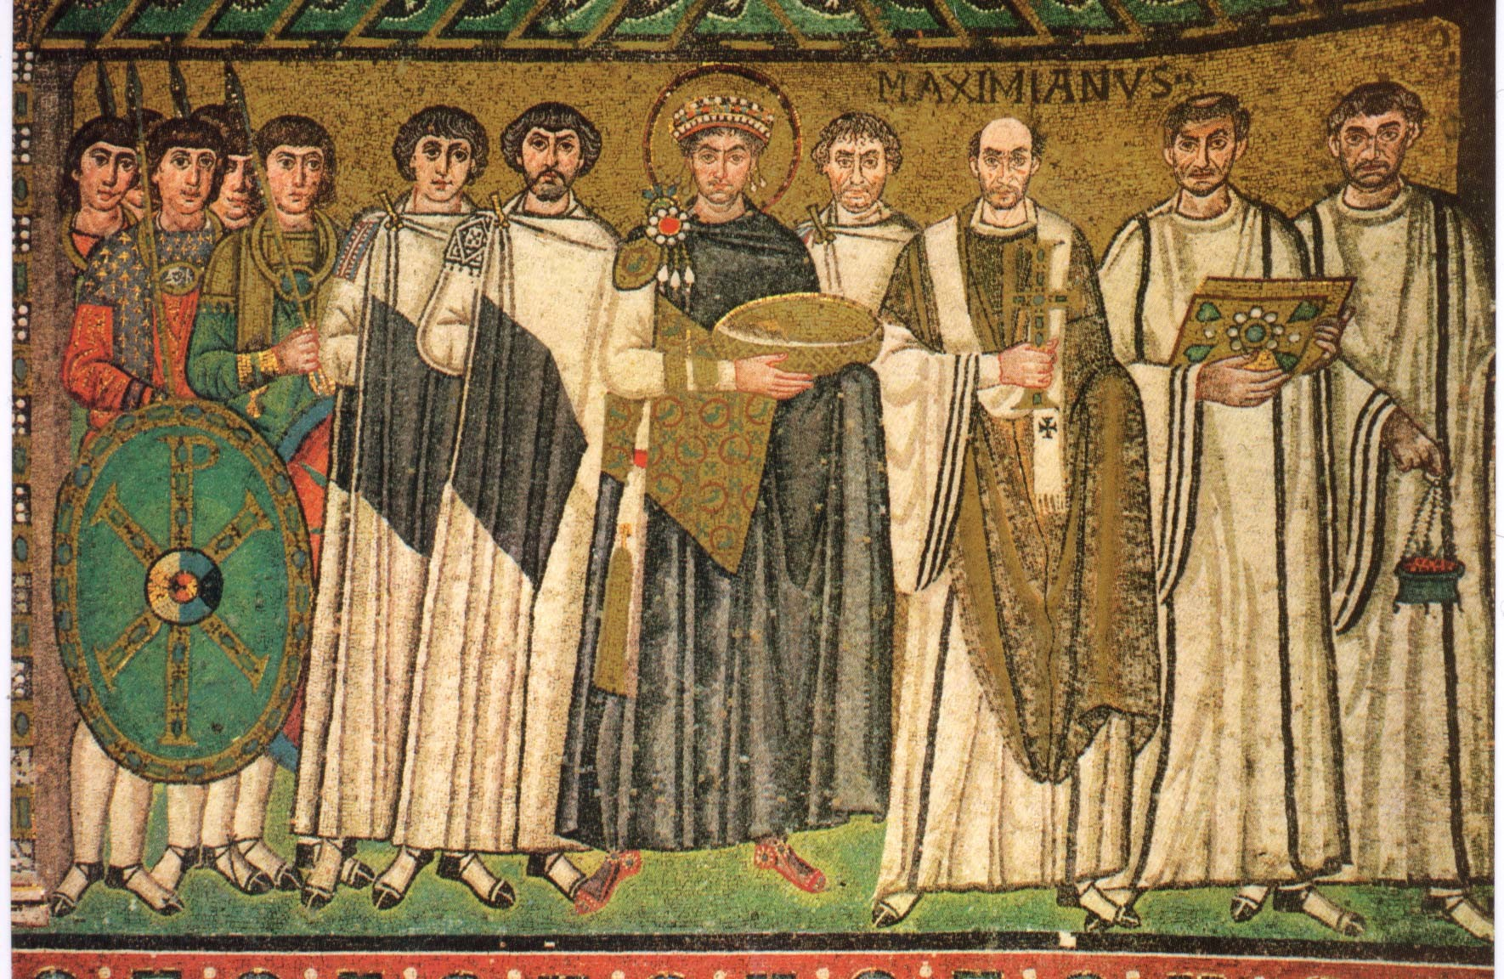

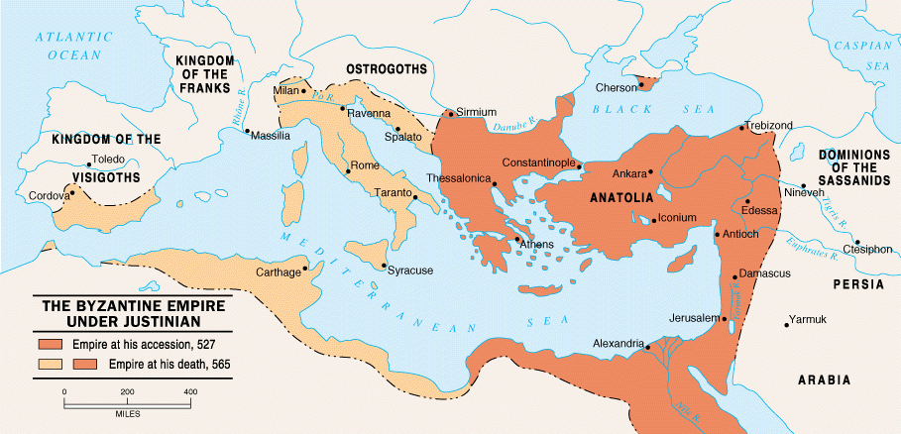

Byzantine Architecture
- Along with the new freedom to practice Christianity came a period of church building due to the demand for public places for ______________________________________________________.
- The old temples of the Roman gods were too small to hold large congregations. Also the Christians did not want to worship in ________________________________________________________.
- The early Christian and Byzantine builders copied the floor plan design of the large Roman assembly hall: the BASILICA, along with much new advancement.
________________________: An ancient Roman floor plan for a style of large building that was used as a meeting place and law court. Consisting of a long nave, apse, open floor plan and high ceilings.  (Label the parts of the basilica on the right) | 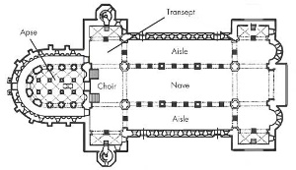
- Most Byzantine architecture was also ___________________ on the exterior. The interiors were _________________decorated with ________________ and __________________.

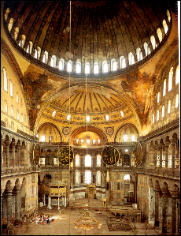  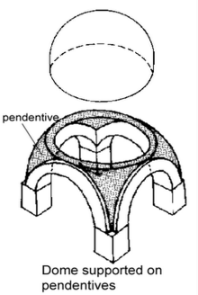  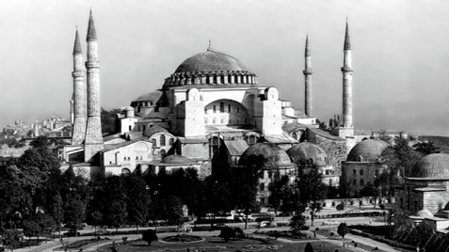 | Most Famous Byzantine Basilica:  - Hagia Sophia - “_________________________”  - Constantinople (Istanbul, Turkey)  - Built by the Emperor ______________________ (very generous to the church)  - Was once the largest church in the world  - Became a ________________ after the fall of Constantinople to the Turkish Muslims  - In order to create a transcendental environment, the ____________ could not be ___________________ as seen in typical vault techniques  - Architects solved this by creating pendentives on top of piers  - This construction allowed for thinner walls housing many windows to ___________________ the interior  - It also created the illusion of a lighter weight.  - Light = symbol of ________________________

Byzantine Art
- Since the Christian focus was on ___________________________ for a glorious afterlife, interest in realistically representing objects _____________________________________.
  - Byzantine artists had to follow a strict set of rules about subject matter, content, and form.
  - Very religious – nudes were _________________________ and even clothed bodies showed _________________________________________________.
  - Mosaics and Fresco paintings
    - __________________________________________________________________________ – theologians believed church members would come to appreciate divine beauty through lavish mosaics and paintings
    - ____________________________________________ became very important
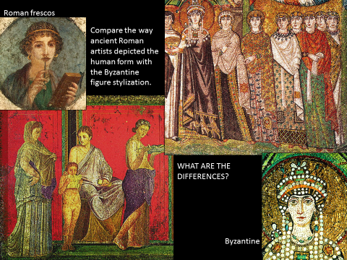

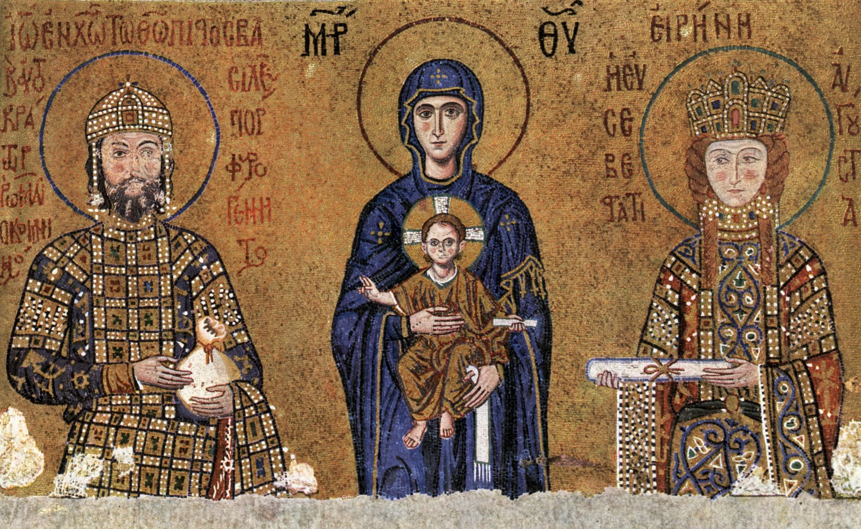
Byzantine Style

  - _________________________ subject matter
  - Figures appear _____________ and fairly _________________
  - Little or no ____________________________
  - Large, dark _________________ stare directly at the viewer
  - ________________________________ faces
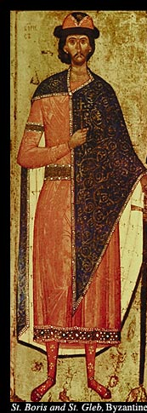
  - Faces appear _____________________________ and generally not ___________ portraits
  - Religious figures often depicted with _____________________________________________
  - Little suggestion of ______________ as figures only overlap to show depth yet all are the __________________________________
  - Clothing appears _________ & linear (seems to be hung on hangers rather than covering 3-D bodies)
  - Figures have __________________________ that do not appear to touch the ground (tippy toed)
  - Bodies are
    - _______________________________________________
    - _______________________________________________
    - _______________________________________________

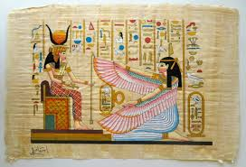
Label the following as Byzantine Art, Greco-Roman Art, & Egyptian Art.
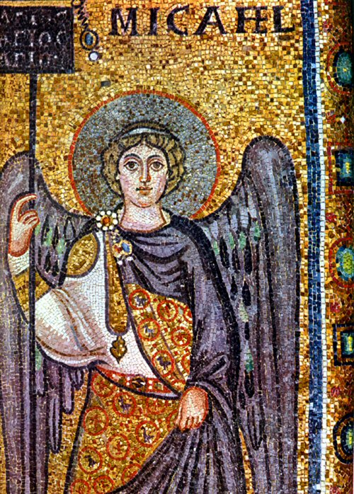
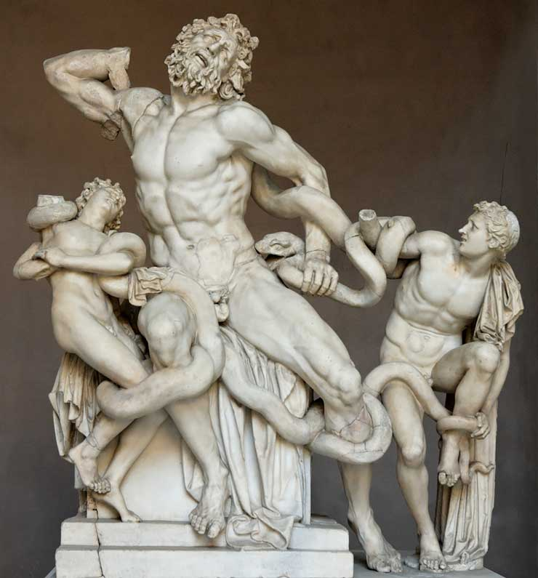

Describe the features of Byzantine art. Compare these features to Greco-Roman and Egyptian art. How are they different? How are they similar?
________________________________________________________________________________________________________________________________________________________________________________________________________________________________________________________________________________________________________________________________________________________________________________________________________________________________________________________________________________________________________________________________________

- ____________________ - A picture or design made of _______________________________ of colored ___________________________________________________________ adhered to a surface. It is typically decorative work for walls, vaults, ceilings or floors, the pieces are set in plaster or concrete and usually on a slight angle to _____________________________________________________.
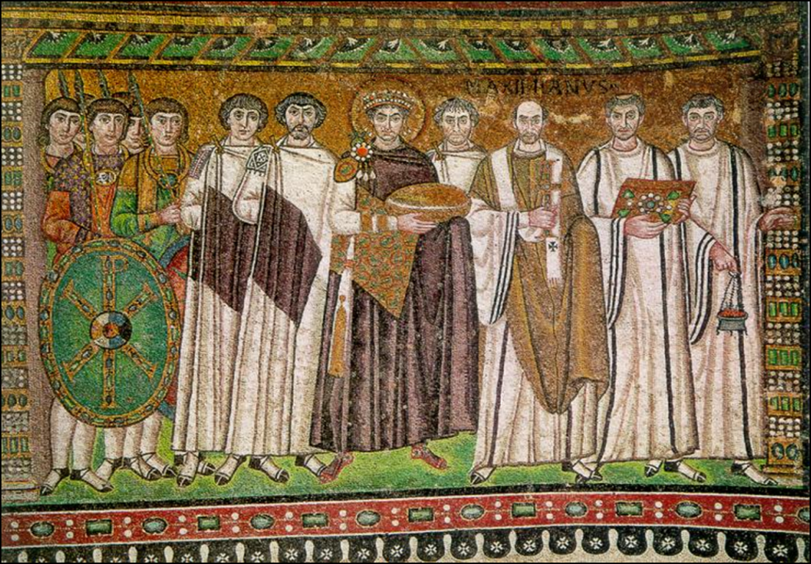
Justinian and Attendants
(547 A.D) is found in the San Vitale Church in Ravenna, Italy. It includes the Emperor Justinian with the archbishop, deacons, soldiers and attendants. Those bodies of ___________________ importance _________________________ those of __________________________________________________.

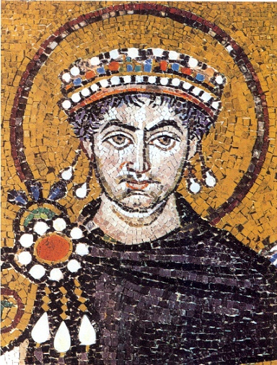

  - The figures are _______________ and _______________________, including:
    - _________________________________ viewpoints
    - _________________________________ of the figure
    - _________________________________ of faces with
      - large ______________________
      - _________________________________ faces
      - decorative ___________________________________.
  - Strong use of __________________________- Bread and wine of Eucharist. ______________ to show that Justinian is Gods holy representative on earth and therefore holy himself.
- Byzantine Icons
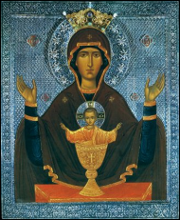
  - ______________ are ________________________________________ under a set of stylistic rules that evolved in the Eastern Roman Empire (Byzantine Empire)
    - Believed to have a ____________________________________ dimension
    - Icons were usually painted on hardwood, sometimes elaborately framed or encased in precious metals and stones
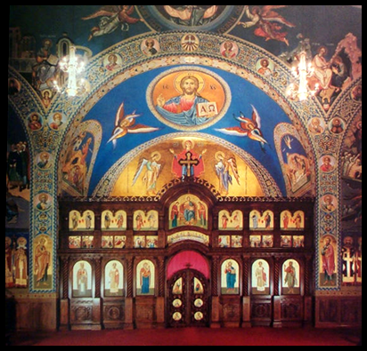
    - Monks & lay artists who painted icons were thought to be divinely inspired. The profession had considerable prestige.
  - ___________________________: a ____________________________ and religious paintings separating the ____________ from the sanctuary in a church (basically an altar screen)

Discussion Questions
  - What might have happened to early Christians if they had expressed their faith openly before 313 AD?
______________________________________________________________________________________________________________________________________________________________________________________________________________________________________________________________________________________________________________________________________________________________________________________________________________________________________________________________________________________________________________________________________________________________________________________________________________________________________________________________________________________________________________________________________________________
  - Why did early Christians use more symbolism in their art than the Romans and the Greeks?
______________________________________________________________________________________________________________________________________________________________________________________________________________________________________________________________________________________________________________________________________________________________________________________________________________________________________________________________________________________________________________________________________________________________________________________________________________________________________________________________________________________________________________________________________________________
  - After Christianity was legalized and the Byzantine Empire flourished, what are some ways that art was censored?
______________________________________________________________________________________________________________________________________________________________________________________________________________________________________________________________________________________________________________________________________________________________________________________________________________________________________________________________________________________________________________________________________________________________________________________________________________________________________________________________________________________________________________________________________________________
  - How does studying Early Christian and Byzantine art relate to our topic of censorship?
___________________________________________________________________________________________________________________________________________________________________________________________________________________________________________________________________________________________________________________________________________________________________________________________________________________________________________________________________________________________________________________________________________________________________________________________________________________________________________________________________________________________________________________________________________________
Study Guide
  - Why did the early Christians have to meet secretly in order to worship?
Early Christians lived in a pagan society and it was against the law to be a follower of Christ.
  - How did the early Christians hide their religion from the Romans?
Early Christians used catacombs to secretly worship.
  - Why didn’t the early Christians want to cremate their dead like the pagans did?
The early Christians believed in bodily resurrection and if they cremated their dead then the soul would not have a body to return to.
  - How did Christianity become legal?
The Roman ruler, Constantine, had a sign from the Christian God and legalized Christianity in 313 AD
  - Why didn’t the early Christians want to worship in the Roman temples?
The early Christians did not want to worship in Pagan temples and they were too small to hold large congregations.
  - Which emperor had the Hagia Sophia built?
Emperor Justinian
  - What do the words Hagia Sophia stand for?
Holy Wisdom
  - Be able to label the parts of a basilica.

  - Describe some differences between Byzantine art and Greco-Roman art:

  - Describe some similarities between Byzantine art and Egyptian art:

  - What was main purpose for creating Early Christian art?
Early Christian art was created to inspire and teach their faith.
  - Be able to recognize Early Christina symbols such as: the fish, the anchor, and the Good Shephard. Also, know what they symbolize.

    - Funerary art was carved with symbolic scenes that advanced the Christian belief of the soul’s life after death. As time passed, the realistic figure proportions and the skill of the sculpting of the Roman times deteriorated. Symbolism became more important than: Realism and design

  - Write B for Byzantine or GR for Greco-Roman in the blank before the description.
GR | Shows more emotion | B | Fully clothed | GR | Portrays the body realistically
B | Expressionless face | GR | Nudes | B | Bodies are elongated, stiff, and stylized

