Name: __________________#________ Block: ________

SURVIVAL GUIDE
Fine Arts Handbook and Frequently Used Documents

Table of Contents

Syllabus………………………………………………………………………………....…….………...…....2
Common Vocabulary Words to Know……………………....………………...……………………...5
Elements and principles of art…………………………………………………………..……………..7
FOUR STEPS OF ART CRITICISM…………………………………………………………….………….9
How to Create a Citation………………………………………………………………………...….….10
ART HISTORY TIMELINE…………………………………………………………………………..........12
Grade Tracker………………………………………………………………………...……………..……..16

syllabus
COURSE DESCRIPTION
This course introduces students to art’s place in the modern world as well as a general survey of art expression, technique, and application. The course is heavily grounded in English/Language Arts course standards and will thereby utilize English principles of reading, writing, reasoning, listening, and speaking skills in every class. Fine Arts is a required course for TOPS.

UNITS OF STUDY
Class Website: http://julieblee.weebly.com/ This website is updated as often as possible with news, announcements, important dates, class assignments, participation guides,corresponding answer keys,links to videos and other websites as well as important dates and information
 | Theme | Big Question
Unit 1 | Art Introduction | What are the basic concepts of art?
Unit 2 | Art and Religion | How has religion impacted art?
Unit 3 | Art and Movement | How can art move?
Unit 4 | Art Practice | How is art expressed?

Remind

Enter this number:
81010

4th block message:
@jlee4

GRADING
The semester is divided into two nine-week periods. In each nine weeks, there will be two units, totaling four units. In each nine weeks, there will be 10 grades: tests, notebook checks, assignments, two exam grades and a participation grade. Students will also be given a Pretest, a Benchmark, and a Post-test to assess their development throughout the course. These assessment also serve as grades.

POLICIES AND PROCEDURES
- Enter class ON TIME. There should be no lingering in the hallway. If you are not in the doorway by the time the tardy bell rings, then you are considered absent and will be written up.
- Raise your hand. There will be time when you are allowed to openly discuss, and you will be made aware of that. Do NOT leave your seat without permission.
- Three bathroom passes will be given to students for the entire semester. If you use/lose your bathroom passes, you are out of luck! If you need to go to the bathroom, I will motion for you to go to the bathroom after you give me your pass. Additional bathroom passes may be given to students to reinforce positive behavior. Bathroom passes can be turned in for bonus points on any assignment.
- Be PREPARED to LEARN. Enter class quickly and quietly.
- Begin your bellwork as soon as you enter the classroom.
- Turn in assignments when due. Bring required materials to class, bring required ATTITUDE to class, and be prepared to TRY.
- There will be NO food, drinks, gum or candy in this room
- THINK BEFORE YOU SPEAK! Think 1. Is this relevant? 2. Is this helpful? 3. Is this necessary? If the answer is no to any of these questions, please keep your thoughts to yourself.
- Follow directions! When I ask you to do something, I expect you to do so in a timely fashion.
- RESPECT EVERYONE AROUND YOU. When in doubt, follow the Golden Rule: Treat others like you want to be treated. Keep your hands and thoughts to yourself. There will be NO name calling or profanity in this classroom. Respect includes giving those around you the attention they deserve, including your teacher, your peers, and anyone else in the classroom
- Be a bucket filler! Don’t dip in other people’s buckets.
- If you are absent, it is YOUR responsibility to see the binder manager/absent binder and find out what you missed.
- You have THREE DAYS to make up any missed work. Any grades not completed by this time will result in an F being entered into the grade book (which means you will get a phone call home!).
- Students should NOT be on their cell phones without a teacher’s specific permission. There will be times when students will be allowed to use their phones for research purposes, but ONLY when specifically stated by the teacher.
- Students are to follow all rules, guidelines, and procedures set by Assumption High School.

Bathroom and Water Breaks:
First, students’ leaving the classroom is at the discretion of the teacher, impacted by student behavior and participation. Additionally, the classroom is located in close proximity to the bathroom and water fountains. Students are expected to utilize minutes between classes to go to the restroom and get water. Otherwise, students will be allowed out of the classroom three times a semester for restroom use/water. Three passes will be given, and they are the responsibility of the student. Lost or stolen passes will not be replaced. Positive behavior can earn you additional passes or tokens and four tokens can purchase a bathroom pass. Unused passes can be used for 5 bonus points on tests and/or exams. All unused bathroom passes will be turned in at the end of the semester for bonus points on the exam.

OTHER POLICIES:

Absences: As indicated in the Assumption Parish code of conduct, students have “up to three (3) days, or a number of days equal to the number of days of consecutive absences, whichever is greater, following the return to class, to make up work. Failure to make up work will result in failing marks for missed assignments/assessments given during the absence.”

Incompletes: Students will receive an I(incomplete) for any missed assignment as well as any formal test that they are unsucessful on. I-Makeups will be scheduled as needed throughout the semester at the teacher’s discretion. Incompletes that have not been taken care of become F’s at the end a grading period. NOTE: It is the student’s responsibility to request and receive work and tests from the days he or she was absent.
Late Work: Any major late work will result in a grade that will be lowered with each additional day which it is late.

Remind: A way to know that’s going on…
What is it? Remind is a website that provides a safe way for teachers to text message or email students and parents.

How do students/parents sign up? Students and parents sign up for notifications by sending a text message with a teacher's class code (e.g. text @code to 81010). They may also sign up by sending an email to the teacher's code (e.g. code@mail.remind.com). The medium they sign up with determines how they will receive notifications. So if a student signs up from her phone, she will receive text messages. Likewise, a parent who emails in will receive messages via email.
4th Block—Text 81010 with this message @jlee4

SUPPLIES
- Binder/Folder - You need something to keep your Fine Arts materials ORGANIZED. This will save you in the long run!
- Lead pens/pencils/writing utensils - This is part of being prepared to learn! Bring something to write with to EVERY class. I will have a limited supply of pencils in my room, but they will cost you two tokens to borrow. If you return the pencil WITHOUT DESTROYING IT, you will get your tokens back. If you damage my supplies, you will not get your tokens back.
- Coloring supplies: markers, crayons, colored pencils, etc. - Several of our activities require you to CREATE.
Community Supplies Community Supplies for Mustang Tokens
4th Block: colored card stock Supply # of Tokens
Clorox wipes 3
Paper/Cardstock/Construction Paper 2
Ruler 1
Hand Sanitizer (Depends on size)

PLEASE REVIEW, SIGN, AND PLACE THIS FORM IN YOUR BINDER:
We have read and agree to the listed behavior expectations, grading information, and
policies for this course. We understand that failure to follow the guidelines may result
in disciplinary action.
Parent Signature Date

______________________________________________________________________
Student Signature Date

______________________________________________________________________

Common Vocabulary Words to Know
2D OR TWO- DIMENSIONAL: things that look flat. For example, a square is a 2-D shape.
3D OR THREE- DIMENSIONAL: things that look (or are) solid. For example, a cube is a 3-D shape.
ABSTRACT: art that does not attempt to represent the appearance of objects, real or imaginary. The artist takes an image or object and changes its appearance by leaving out details, simplifying or rearranging its parts to express his or her idea or feeling. Abstraction can occur in varying degrees, perhaps to the extent where you may not recognize the subject in the final product. Abstract work with no recognizable subject matter is called non-objective art.
ABSTRACT EXPRESSIONISTS: a group of New York artists of the 1940's-50's, including Jackson Pollock. They made abstract works meant to express their feelings.
AESTHETIC: the science of the beautiful in art; defined by visual, moral, social, and contemporary standards.
ARCHITECTURE: the art of making plans for buildings or a style of building
ART: things made to be looked at, especially paintings and sculptures. It can also be used to describe anything creative, including music and poetry.
ART CRITICISM: describing and evaluating the media, processes, and meanings of works of visual arts, and making comparative judgments
ART ELEMENTS: visual arts components such as line, texture, color, form, value, and space
ART HISTORY: a record of the visual arts, incorporating information, interpretations, and judgments about art objects, artists, and conceptual influences on developments in the visual arts
ART MOVEMENT: a group of artists who work together and share ideas, and often hold joint exhibitions
ASYMMETRICAL: different on either side of a central axis
BALANCE: equilibrium in a composition, either symmetrical or asymmetrical
CALLIGRAPHY: fine handwriting in ink with a quill, reed pen, or brush; follows specific rules or designs
CHIAROSCURO: the use of light and shadow to create a focal point or mood
CLASSICAL: originating in Greece and Rome; represents unadorned beauty
COLOR WHEEL: an arrangement of colors that shows how to mix the primary colors to create new colors
COMMISSION: the hiring of one or more artists to create a work of art
CONTEMPORARY ART: generally defined as art produced during the second half of the 20th century.
CONTOUR LINES: outside and inside lines defining an image or shape
CONTRAST: to set in opposition for the purpose of comparison
CROSSHATCH: to create differences in value through a crossed series of parallel lines
CUBISM: natural forms changed by geometrical reduction
DEPTH: the illusion of space in a picture plane.
DESIGN: the organization of line, form, color, value, texture and space in an eye-pleasing arrangement
ELEMENTS OF ART: the visual "tools" artists use to create art. The categories include line, color, shape, space, light and texture
EMPHASIS: a design principle that gives dominance to a particular area through color, size, or repetition
EXPRESSIONISM: the painting of feelings, sometimes with recognizable images, often totally abstract
FIGURE: the human or animal form used in creating art
FOCAL POINT: an area of an artwork that first attracts and usually sustains the viewer's attention
FOREGROUND: in a scene or artwork, the part that seems closest to the viewer
FORM: a three-dimensional shape, such as the human form or an abstract form
FOUND OBJECT: an object which an artist has not made, but has chosen to exhibit as a work of art. It can be a natural object, such as driftwood, or a man-made object such as a bottle
FRESCOS: wall paintings made by painting onto wet plaster
GENRE: subjects and scenes depicting everyday life. Or, a particular kind of paintings, such as portraits, landscapes, and still lifes
HIGHLIGHT: a light area that represents the reflection of light
HORIZON LINE: a level line where water or land seems to end and the sky begins. It is usually on the eye level of the observer. If the horizon cannot be seen, its placement may be imagined based on the placement of trees, grasses, mountains and the like.
HORIZONTAL: side to side and parallel to the horizon
HUE: refers to the common name of the color such as red or green
IMPASTO: thick, opaque paint applied with a brush, knife or fingers, creating various textural features on the surface of the painting
IMPRESSIONISM: a style of painting that seeks to represent the momentary effects of sunlight on color. The main interest was in depicting contemporary life in a new objective manner by rendering an "impression" of what the eye sees in one particular moment rather than what the mind knows to be there
ITALIAN RENAISSANCE: revival of classical art, literature, and learning based on humanism
KITSCH: artwork, often mass produced, that goes beyond good taste
LANDSCAPE: the scenery of an inland area, a painting or drawing of the land or natural environment
LINE: the path traced by a moving point
LITHOGRAPH: a print made by drawing on a flat, porous limestone with greasy material, then applying greasy ink which adheres only to the drawn lines. Dampened paper is applied to the stone and is rubbed over with a special press to make the final print
MEDIUM: the material used to make a work of art. Examples include oil, watercolor, pencil, pen and ink, tempera, and pastel
MIDDLEGROUND: the part of the painting that lies between the background and the foreground
MIXED MEDIA: used to describe art made from more than one material or medium
MOSAIC: a design or picture created by embedding stones or pieces of glass on a floor, vault or wall
MURAL: a large painting or artwork, generally designed for and created on the wall or ceiling of a public building
NEGATIVE SPACE: the area surrounding a shape, often seen as a void
OPAQUE: ability of paint to cover over a surface. Not seen through
OPTICAL ILLUSION: image that appears different than it actually is
PATRONS: people who pay artists to produce work for them
PATTERN: a design made by repeating a motif at regular intervals
PERSPECTIVE: a technique for creating the illusion of depth on a 2-D surface
POINTILLISM: the application of pure color in small dots, allowing the eye to mix (such as red and blue dots side by side, which the eye sees as violet). It was developed in 1855 by Georges Seurat.
POP ART: a mid-20th-century British and American art movement which used images from popular culture, such as comic strips and advertisements. Andy Warhol was a famous Pop artist.
PORTRAIT: a picture of a person or images that portray a person
POST-IMPRESSIONISM: a term used to describe the variety of styles that developed in the 1880's-90's following Impressionism. It includes the work of Cezanne, Gauguin, and van Gogh.
PROPORTION: the relationship of one object to another in size, shape, number or degree
RADIAL DESIGN: branching out from the middle.
REALISM: (1850-1900) a style in which an artist tries to create an image that resembles the natural world
RENAISSANCE: a period in the 15th and 16th centuries when there were lots of new discoveries in art and science.
REPETITION: recurring again and again
RHYTHM: the controlled movements found in all good design, they can be established through the use of any of the elements of design--lines, areas of light and shade, spots of color, repetitions of shapes and spaces, or textures surfaces
ROMANTICS: a group of late 18th and early 19th-century artists, including Caspar David Friedrich, who were inspired by a love of nature
SFUMATO: a smoky, hazy effect with soft edges
SHADE: any color mixed with black
SHAPE: the outline of a figure or form. Shapes can be geometric (rectangles, triangles, and circles, etc.) or organic (irregular)
SILHOUETTE: portrait or picture cut from black paper or done in solid black upon a light background
SPACE: Actual: 2D space as in drawings, paintings or prints on flat surfaces, or 3D as in sculptures, architecture or ceramics
Pictorial: the flat surface of the paper, canvas, or other material and is also known as the picture plane
STILL LIFE: an arrangement of fruit, flowers, food or assorted unmoving objects. The plural is "still lifes" (not "lives").
STUDY: a drawing that may be used to try out an idea or plan out another work
SURREALISM: a 20th-century art movement which used bizarre, dream-like images. Rene Magritte and Salvador Dali were famous Surrealists.
SYMMETRY: the placement of the same elements on either side of a dividing line in such a way that they form a mirror image of each other
TEXTURE: the way something feels to the touch. Texture can be real, as in the smoothness of a bronze sculpture, or the bumpiness of thick oil paint on a canvas. Texture can also be implied or imagined, as in painted illusions of the softness of a kitten's fur, or the prickly quality of hay
THEME: the main idea underlying the subject in a work of art
VALUE: the measurement of light and darkness in a work of art
VANISHING POINT: term used in perspective; all lines lead to this point which may be on or off the canvas
VERTICAL: up and down
VISUAL TEXTURE: texture that you can see or that an artist will decorate a surface with. You can not feel visual texture

Elements and principles of art
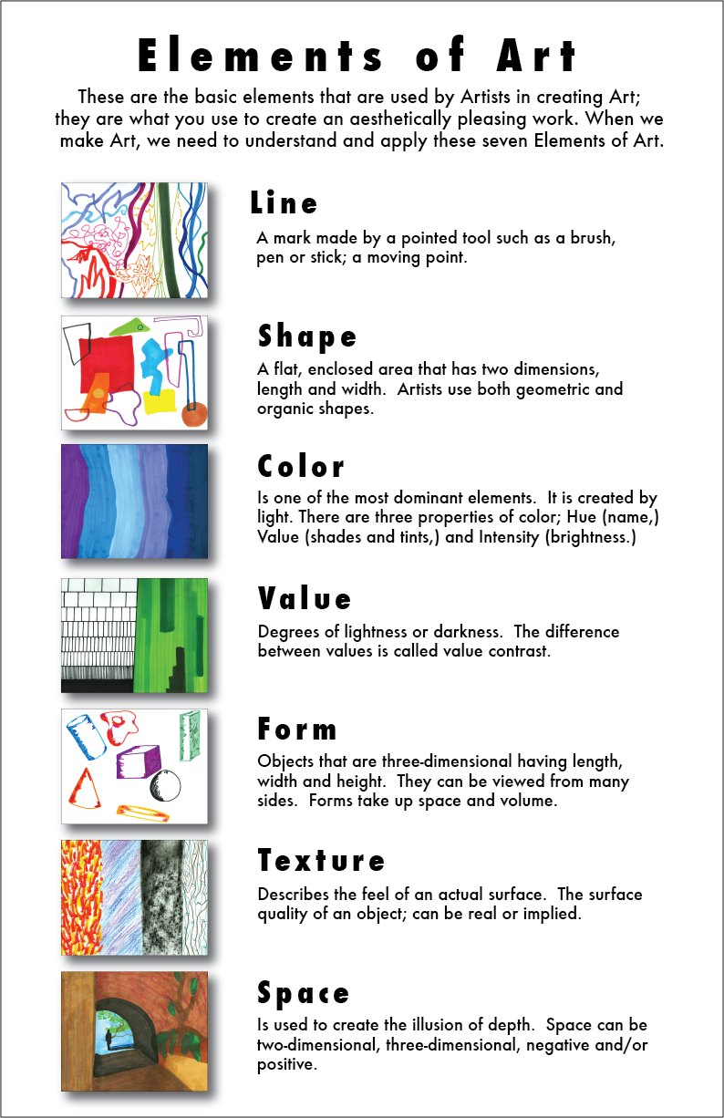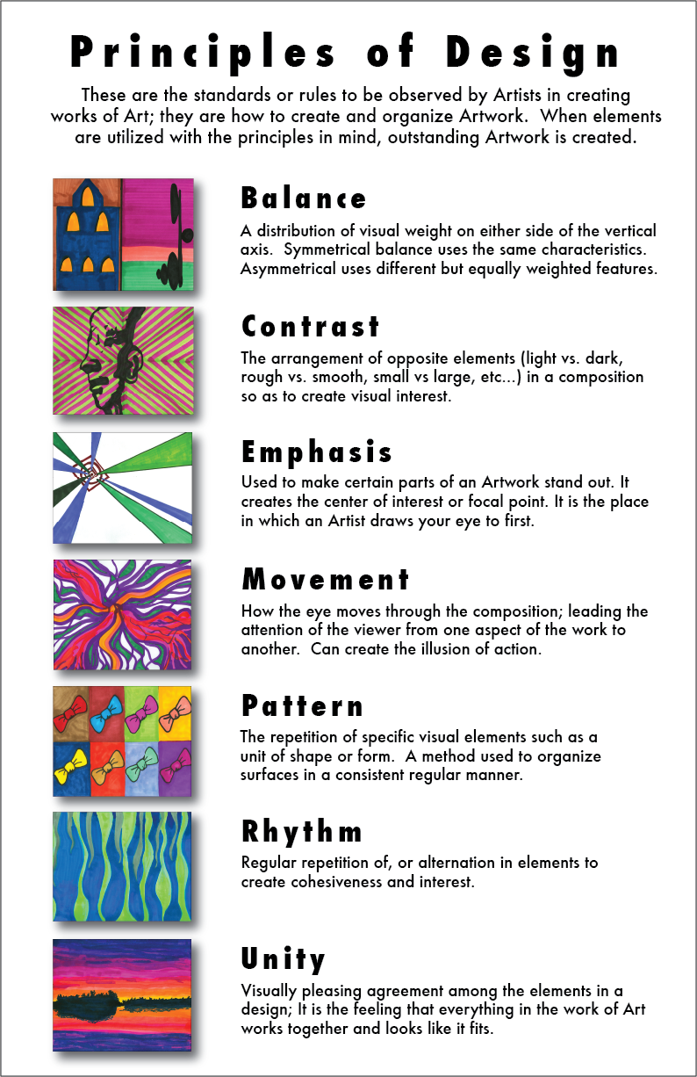
FOUR STEPS OF ART CRITICISM
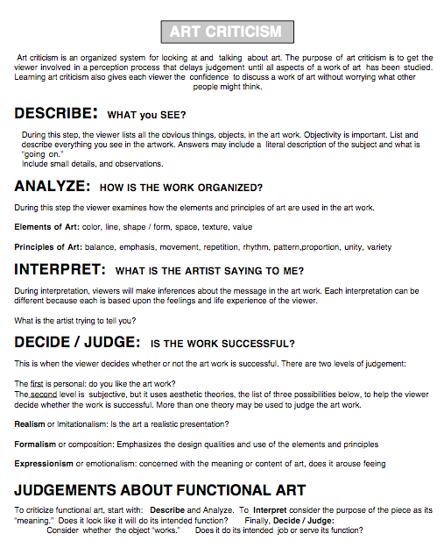
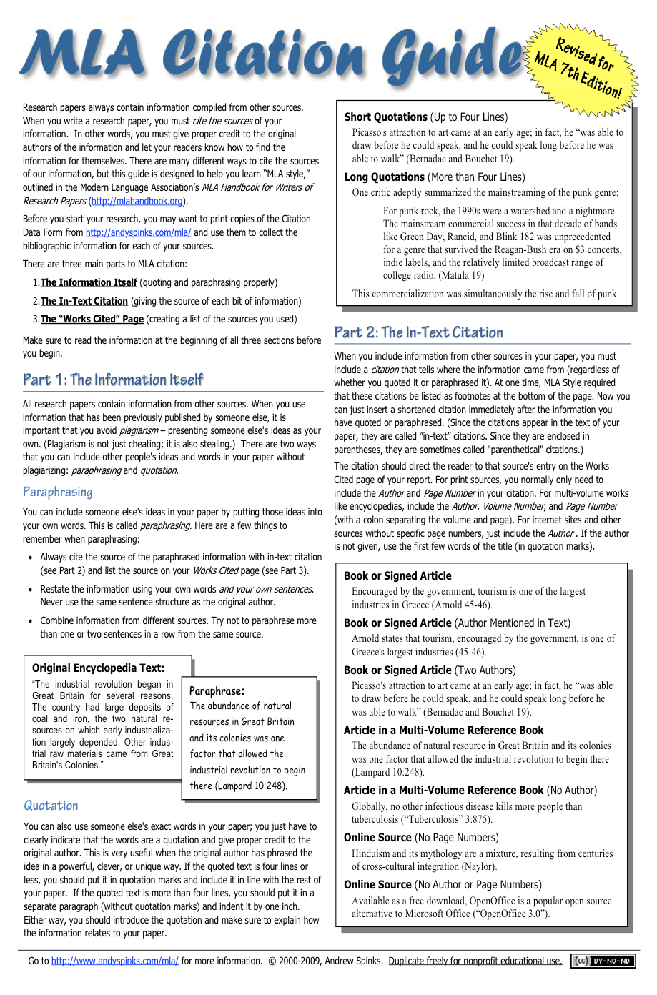
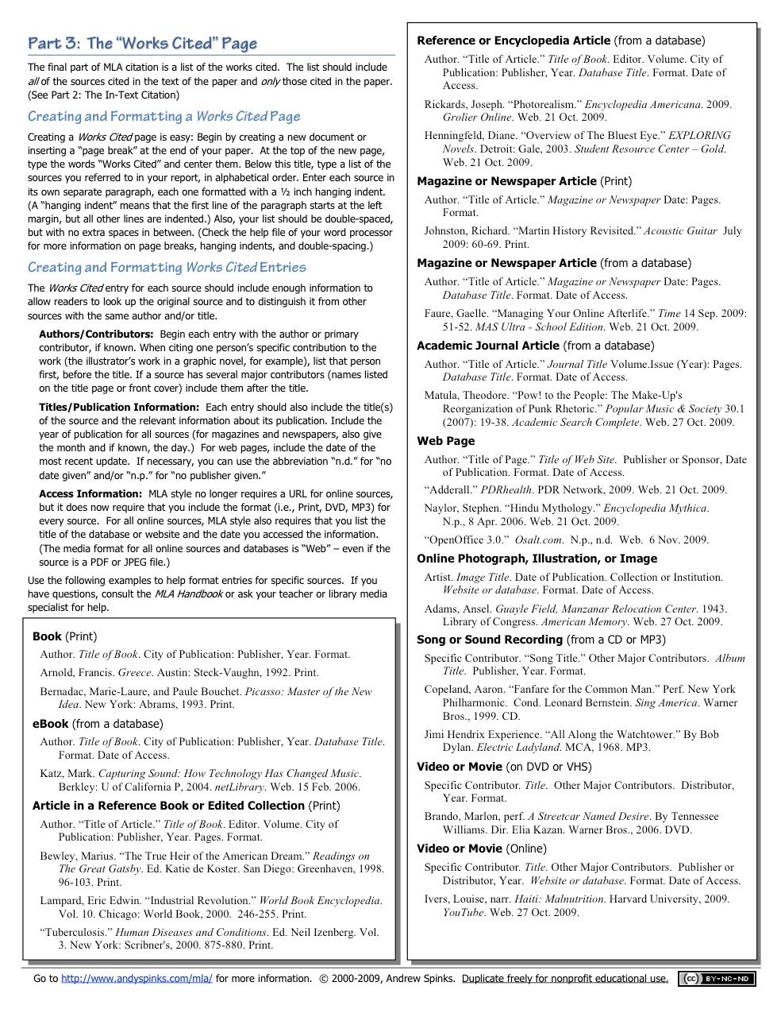
ART HISTORY TIMELINE
http://www.metaphorandart.com/articles/images/Brandl_Art%20_History_Timeline_14_jpg-1.jpg
History of Art Timeline
ERA | PERIOD/MOVEMENT | CHARACTERISTICS | CREATORS/WORKS | HISTORICAL EVENTS/ CONTEXT
Prehistoric | 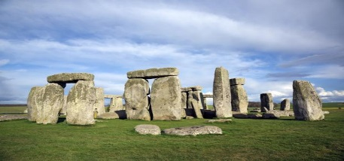  Pre-historic Art  - 30000 B.C.- 2200 B.C | 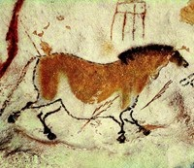  Cave painting, fertility goddesses, megalithic structures | Lascaux Cave Painting, Woman of Willendorf, Stonehenge | Ice Age ends (10,000 b.c.– 8,000 b.c.); New Stone Age and first permanent settlements (8000 b.c.– 2500 b.c.)
Antiquity, Ancients, Classical | Persian Art  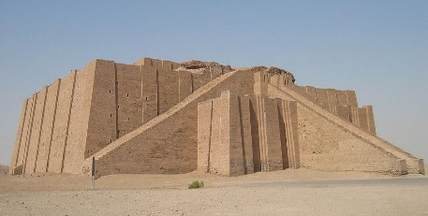  - 3500 B.C.- 330 B.C.
 | Mesopotamian Art  - 3500 B.C.- 540 B.C | 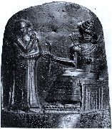  Warrior art and narration in stone relief | Standard of Ur, Ziggurat of Ur, Head of Akkadian Rule Gate of Ishtar, Stele of Hammurabi's Code | Sumerians invent writing (3400 b.c.); Hammurabi writes his law code (1780 b.c.); Abraham founds monotheism
 | 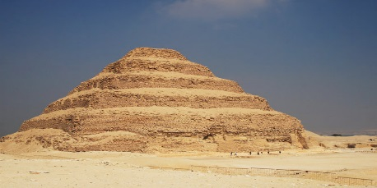  Egyptian Art  - 3000 B. C.- 400 | 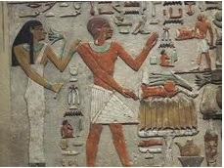  Art with an afterlife focus: pyramids and tomb painting | 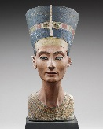  Imhotep, Step Pyramid, Great Pyramids, Bust of Nefertiti | Narmer unites Upper/Lower Egypt (3100 b.c.); Rameses II battles the Hittites (1274 b.c.); Cleopatra dies (30 b.c.)
Celtic Art
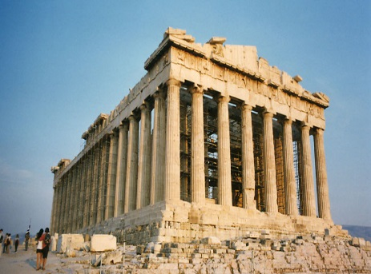
- 1000 B.C.- 1000
 | Grecian & Hellenistic Art  - 850 B.C.- 31 B.C. | 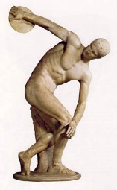  Greek idealism: balance, perfect proportions; architectural orders(Doric, Ionic, Corinthian) | 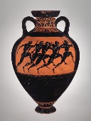  Parthenon, Myron, Phidias, Polykleitos, Praxiteles | Athens defeats Persia at Marathon (490 b.c.); Peloponnesian Wars (431 b.c.–404 b.c.); Alexander the Great's conquests (336 b.c.–323 b.c.)
Etruscan Art
- 700 B.C.- 90 B.C.
 | 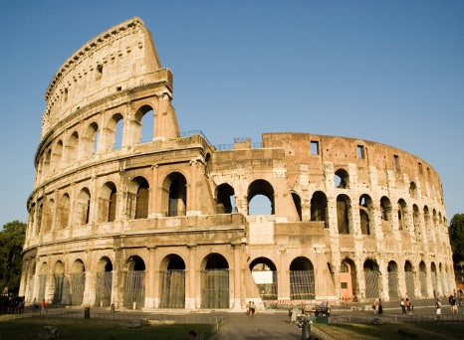  Roman Art  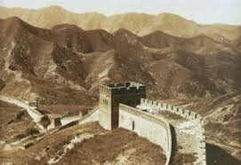  - 500 B.C.- 400 | 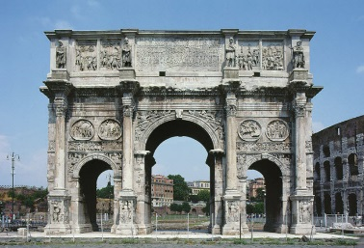  Roman realism: practical and down to earth; the arch | Augustus of Primaporta, Colosseum, Trajan's Column, Pantheon | Julius Caesar assassinated (44 b.c.); Augustus proclaimed Emperor (27 b.c.); Diocletian splits Empire (a.d. 292); Rome falls (a.d. 476)
 | Asian Art  - 650 B.C.-1900 | 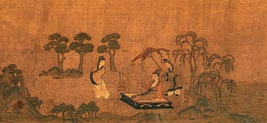  Serene, meditative art, and Arts of the Floating World | 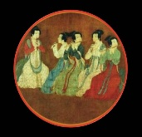  Gu Kaizhi, Li Cheng, Guo Xi, Hokusai, Hiroshige | Birth of Buddha (563 b.c.); Silk Road opens (1st century b.c.); Buddhism spreads to China (1st–2nd centuries a.d.) and Japan (5th century a.d.)
Early Christian Art
- 150- 525
ERA | 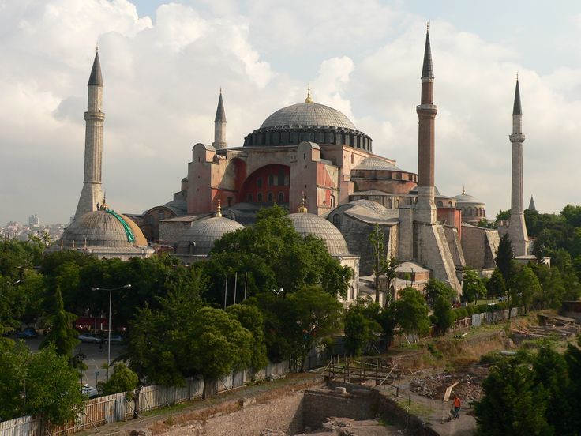  PERIOD/MOVEMENT | CHARACTERISTICS | CREATORS/WORKS | HISTORICAL EVENTS/ CONTEXT
Medieval, Middle Ages | Byzantium Art  - 320- 1450 | 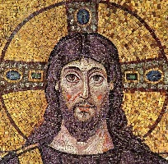  Heavenly Byzantine mosaics; | 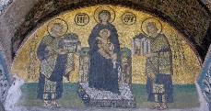  Hagia Sophia, Andrei Rublev, Mosque of Córdoba, the Alhambra | Justinian partly restores Western Roman Empire (a.d. 533–a.d. 562); Iconoclasm Controversy (a.d. 726–a.d. 843)
 | Ottoman Art  - 620- 1920 | 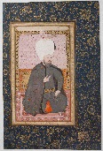  Islamic architecture and amazing maze-like design | 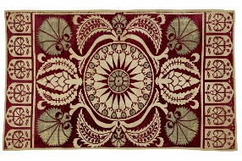 | Birth of Islam (a.d. 610) and Muslim Conquests (a.d. 632–a.d. 732)
 | 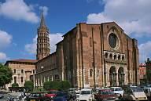  Romanesque  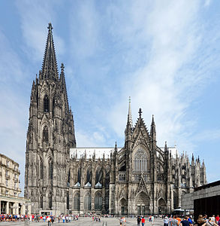  - 1000- 1200 | 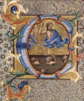  Inspired by roman architecture, such as rounded arches and columns; illuminated manuscripts | St. Sernin, Durham Cathedral, Chartres, Cimabue, Duccio, | Viking Raids (793–1066); Battle of Hastings (1066); Crusades I–IV (1095– 1204);
 | Gothic  - 1140-1375 | 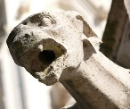  Height & light; Stain-glassed windows; gargoyles | 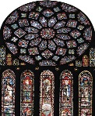  Notre Dame, Giotto, Lamentation of Christ | Black Death (1347– 1351); Hundred Years' War (1337–1453)
Renaissance | Early & High Renaissance  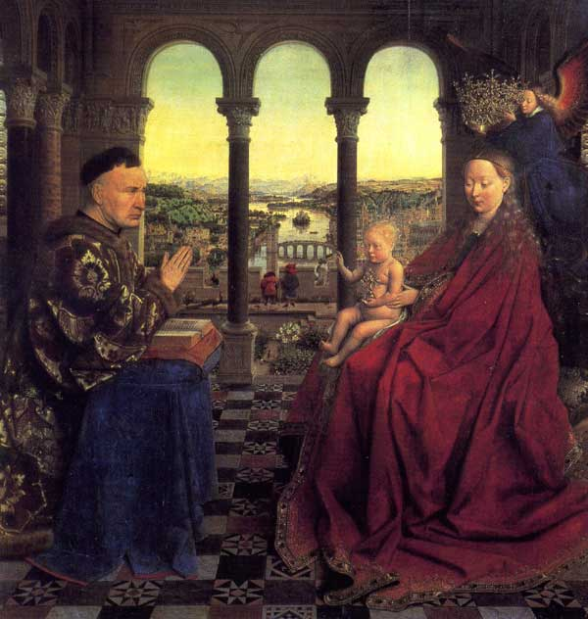  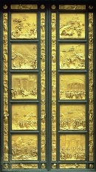  - 1400- 1550 | 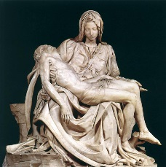  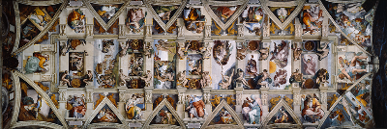  Rebirth of classical culture | Ghiberti's Doors, Brunelleschi, Donatello, Botticelli, Leonardo, Michelangelo, Raphael | Gutenberg invents movable type (1447); Turks conquer Constantinople (1453); Columbus lands in New World (1492); Martin Luther starts Reformation (1517)
 | Venetian & Northern Renaissance  - 1430- 1550 | 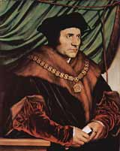  The Renaissance spreads north- ward to France, the Low Countries, Poland, Germany, and England | 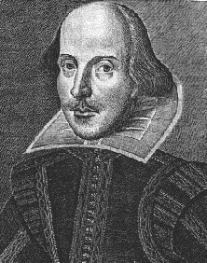  Bellini, Giorgione, Titian, Dürer, Bruegel, Bosch, Jan van Eyck, Rogier van der Weyden, Holbein, Shakespeare | Council of Trent and Counter-Reformation (1545–1563); Copernicus proves the Earth revolves around the Sun (1543
 | Mannerism  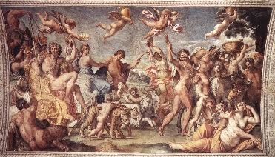  - 1527- 1580 | Art that breaks the rules; artifice over nature | Tintoretto, El Greco, Pontormo, Bronzino, Cellini | Magellan circumnavigates the globe (1520–1522)
Modern- 17th Century | Baroque  - 1600- 1750 | Splendor and flourish for God; art as a weapon in the religious wars | Reubens, Rembrandt, Caravaggio, Palace of Versailles | Thirty Years' War between Catholics and Protestants (1618–1648)
Modern- 18th Century | 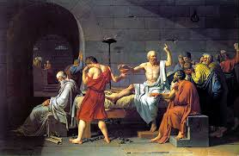  Rococo  - 1700- 1800
 | Neoclassical  - 1750-1850 | Art that recaptures Greco- Roman grace and grandeur | David, Ingres, Greuze, Canova | Enlightenment (18th century); Industrial Revolution (1760–1850)
 | 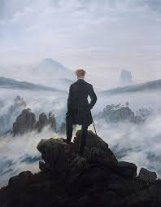  Romanticism  - 1780- 1850 | The triumph of imagination and individuality | Caspar Friedrich, Gericault, Delacroix, Turner, Benjamin West | American Revolution (1775–1783); French Revolution (1789–1799); Napoleon crowned emperor of France (1803)

ERA | PERIOD/MOVEMENT | CHARACTERISTICS | CREATORS/WORKS | HISTORICAL EVENTS/ CONTEXT
Modern- 19th Century | 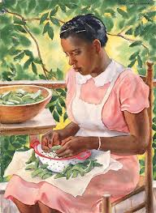  Realism  - 1848- 1900 | Celebrating working class and peasants; en plein air rustic painting | Corot, Courbet, Daumier, Millet | European democratic revolutions of 1848
 | 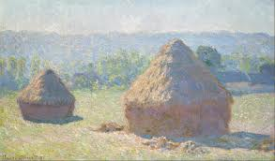  Impressionism  - 1865-1885 | Capturing fleeting effects of natural light | Monet, Manet, Renoir, Pissarro, Cassatt, Morisot, Degas | Franco-Prussian War (1870–1871); Unification of Germany (1871)
 | 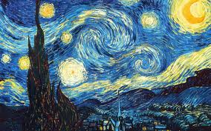  Pointillism  - 1884-1904 | 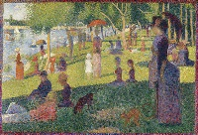 | Seurat, Signac
 | Post- Impressionism  - 1885- 1910 | A soft revolt against Impressionism | Van Gogh, Gauguin, Cézanne, Seurat | Belle Époque (late-19th- century Golden Age); Japan defeats Russia (1905)
Modern- 20th Century | 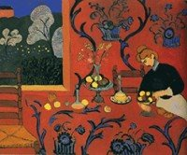  Expressionism & Fauvism  - 1900- 1935 | Harsh colors and flat surfaces (Fauvism); emotion distorting form | Matisse, Kirchner, Kandinsky, Marc | Boxer Rebellion in China (1900); World War (1914– 1918)
 | 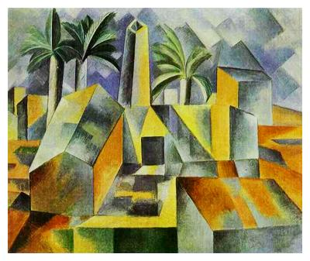  Cubism, Futurism, & Constructivism  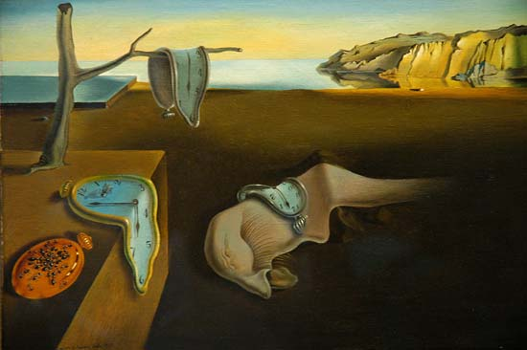  - 1905- 1920 | Pre– and Post–World War 1 art experiments: new forms to express modern life | Picasso, Braque, Leger, Boccioni, Severini, Malevich | Russian Revolution (1917); American women franchised (1920)
 | Dada & Surrealism  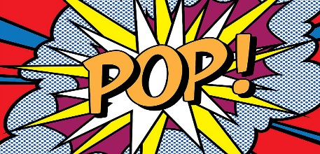  - 1917-1950 | Ridiculous art; painting dreams and exploring the unconscious | Duchamp, Dalí, Ernst, Magritte, de Chirico, Kahlo | Disillusionment after World War I; The Great Depression (1929–1938); World War II (1939–1945) and Nazi horrors; atomic bombs dropped on Japan (1945)
 | Abstract & Pop Art  - 1940- 1960 | Post–World War II: pure abstraction and expression without form; popular art absorbs consumerism | Gorky, Pollock, de Kooning, Rothko, Warhol, Lichtenstein | Cold War and Vietnam War (U.S. enters 1965); U.S.S.R. suppresses Hungarian revolt (1956) Czechoslovakian revolt (1968)
Modern- Contemporary | 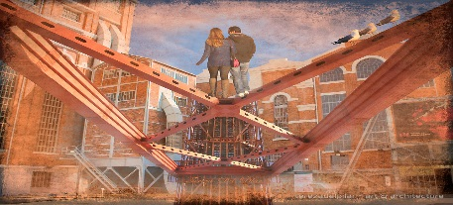  Postmodernism & Deconstructivism  - 1970- | Art without a center and reworking and mixing past styles | Gerhard Richter, Cindy Sherman, Anselm Kiefer, Frank Gehry, Zaha Hadid | Nuclear freeze movement; Cold War fizzles; Communism collapses in Eastern Europe and U.S.S.R. (1989–1991)

Fine Arts Grade Tracker

Title of Assignment | Grade | Quality points  (A = 4, B = 3, C = 2, D = 1, F = 0)
2.
3.
4.
5.
6.
7.
8.
9.
10.
11.
12.
13.
14.
15.

