Name: ________________________________________ Block: __________

First Week Notebook Check
1.
2.
3.
4.
5.
6.
7.
8.
9.

Notebook check #1: Course Intro
Complete each of the following and get initials/stamp from me to indicate their completion.

Teacher
Initials Task

____Have a syllabus signed by student and guardian
____Signed-up for Remind
____Turned/brought in all required supplies for the course. (see syllabus)
____Send an email to me that is written using proper email etiquette:
- The subject line should include course (Fine Arts), Block, and your name (first and last)
- The body of the email should include a salutation, mention who you are and why you are sending the email, a brief description about yourself, and your signature.
- Teacher email: jlee@assumptionschools.com

____Attach completed Student Information Sheet

Notebook check #2
Reflection on _____________________
Reflect on your experience by addressing ONE question from each section on this sheet. Be sure to create correct and complete sentences.
What? (Observation)
• What did you think initially? • What did you learn from this experience?• What skills did you use? • What were the problems, if any?

So What? (Analysis)
• How did you feel about the activity? • Was this an educational experience?
• What did you learn about the people you were helping? • What did you learn about yourself? • What significant knowledge did this project teach you? •What would you have done differently?

Now What? (New or Additional Applications) Think about group work.
• How has your perspective changed since this experience? Have you formed any new opinions? • What are you going to do now as a result of your experience? How are you going to apply your new understanding?

Closing (Synthesis)
• If you could file away one photograph in your mind from this activity, what would it be?• What will you remember most about this experience?

Notebook check #3
Fine Arts Speed Dating
True love? New bestie? Let’s get weird.
- No judgement! This is meant to be a silly get to know you activity. You have 2 minutes.
- Introduce yourself.
- Ask your partner a funny (appropriate question) or use one of the ones provided. Record his/her answer in the chart.
- Answer the question asked by your partner.

Name | Question # | Response

- What is your favorite cereal?
- What is your favorite TV show?
POSSIBLE SPEED DATING QUESTIONS
- What is the most embarrassing thing you’ve ever done?
- If you had to get a tattoo, what would it say?
- What was your best Halloween costume?
- What is your biggest fear?
- What is your favorite song?
- What would you do if you only had 24 hours left to live?
- What is your favorite ice cream flavor?
- What is your dream job?
- Which way do you eat corn on the cob?
- If you had $1,000,000, what would you buy?
- What is your nickname?
- Who is your favorite cartoon character?
- If you could be any animal for 24 hours, what would it be?
- What is your biggest pet peeve?
- What is your talent?
- What is your favorite sport?
- What is your middle name?
- If you could be a cereal box character, who would you be?
- If you could be any punctuation mark, what would you be?
- What is the longest book you’ve read?
- If you could visit any place, what would it be?
- If you were to invent a gadget, what would it be?
- Do you rather the frosting or the cupcake?
- What sport would you compete in if you were in the Olympics?
- If you could erase one day in history, what would it be?
- If someone Googled your name, what would pop up?
- If you were a llama where would you get your hair cut?
- Do you like things store-bought or handmade?
- What is your favorite food?
- What is your favorite pie?
- Do you rather silver or gold jewelry?
- Name all the trees in your yard.
- What is your favorite soup?
- Are you a planner or procrastinator?
- What is your favorite board game?
- What is your favorite element on the periodic table?
- If you could be any Disney character who would you be?
- What is the funniest thing you’ve done that your parents still talk about?
- How many brothers and sisters do you have?
- When is the last time you climbed a tree?
- What was your favorite vacation?
- If you had to mix three animals to make the ultimate animal, what would they be?
- What was your most dramatic car trouble?
- What is the best sound effect you can make? Do it.
- What is your favorite band?
- What is your favorite quote?
- If you could be any color for a day, what color would you be?
- On a scale of 1-10 using fruits and vegetables, what is your favorite number of the alphabet? If you were given $1,000 and had to spend it in a hour, what would you do?
- What is your favorite cartoon from your childhood?
- What’s the weirdest dream you’ve ever had?
- Would you rather fight one horse sized duck or 50 duck sized horses?
- Would you rather spend the night in your washing machine or your dryer?
- Would you rather be a ninja or be a pirate?

Once you’ve finished speed dating, draw a picture in the space that represents your feelings about the class based on the different personalities that you’ve encountered in this exercise.

Notebook Check #4
Two Truths and a Lie/50 Words
Write down your two truths and one lie. Do not share this with your group.
Truth: ________________________________________________________________________
Truth: ________________________________________________________________________
Lie: ___________________________________________________________________________

Before you can begin your micrography project, you will need to come up with AT LEAST 50 individual APPROPRIATE AND POSITIVE words about yourself. These will be the words you will reference while creating your micrography. Your micrography will be a separate grade, but these words will be part of THIS notebook check grade. List your NUMBERED 50 words in the blank space below.

NOTEBOOK CHECK 5: Micrography Project Rubric - 50 Points
- Used time wisely ______ 10
- Name is on the back of final product ______ 5
- Work is visual representation of artist ______ 5
- Words are used to outline and fill in artist’s portrait ______ 10
- Words and phrases represent the artist’s personality ______ 5
- Work is done in color with no stray pencil marks ______ 5
- Work is complete ______ 10

NOTEBOOK CHECK 6: Elements and Principles of Art Project (50 points)
Elements and Principles of Art Project Rubric
- Used time wisely and name is on the back of final products
- The actual element or principle word is the focus of the art
- Work represents elements for element project
- Work represents principles for principle project
- Work is done in color with no stray pencil marks

Notebook check #7
Elements and Principles of Art Note-taking Guide
http://prezi.com/kennrweewf1n/?utm_campaign=share&utm_medium=copy&rc=ex0share

Elements of Art
Definition: The basic ________________________ artists use to ________________ works of visual art. The elements are:
- ________________________
- ________________________
- ________________________
- ________________________
- ________________________
- ________________________
- ________________________
Example of line

- Line - a ________________________ mark made on a surface by a drawing ________________________

Example of Line
Types of line:
  - ________________________
  - ________________________
  - ________________________
  - ________________________
  - ________________________
  - ________________________
Example of shape

Example of Shape

- Shape - an ________________________ area determined by line, value, ________________________, space, or any combination of these elements. A shape is ________________________ or flat two dimensions: ________________________ and ________________________
Example of form

Example of Form

- Form - ________________________ and encloses ________________________. Form has length, width, and also, ________________________ (CAN BE PERCEIVED)
- Value - Changes from dark to ________________________ areas used to create the illusion of ________________________ on a two dimensional ________________________ .

Example of Value

- Texture - refers to how a ________________________ surface ________________________ or ________________________ like it feels

Example of Texture

Example of Space

- Space - Defines the ________________________ areas between, around or ________________________ an object. Positive space is filled by a ________________________ or form. Negative space is the ________________________ areas around or within a shape or form.

Primary Colors

- Color - A color has ________________________ (color name), intensity (________________________ ), and value (lightness or ________________________ ). The “Color Wheel” is the ________________________ artists use to identify primary, secondary, and tertiary colors, and group color ________________________ .

Principles of Design
Definition: Ways artists ________________________ the elements of art in works of ________________________ art.
They are:
- ________________________
- ________________________
- ________________________
- ________________________
- ________________________
- ________________________
- ________________________
- ________________________

- Balance - How parts of an ________________________ are arranged to create a sense of ________________________ or interest.
  - Common types are ________________________, ________________________, and ________________________.

Symmetrical Asymmetrical Radial

- Emphasis - When an artist arranged a ________________________ to place greater ________________________ on certain areas and objects to create a feeling in a work of art. This could be considered a “___________________ _________________”
- Proportion - the ________________________ of one object to another in ________________________, amount, ________________________, or degree.
- Unity - How the ________________________ and principles work together to create a sense of oneness or ________________________ in a work of art.
- Rhythm - Combining elements through ________________________, alteration, or progression of an art ________________________ to create ________________________
- Pattern - repeating ________________________ or a combination of elements in a planned way
- Movement - Referring to a way of combining visual elements to ________________________ the viewer's eye through the piece or ________________________ a sense of ________________________
- Variety - The use of ________________________ elements of design to hold the viewer’s ________________________ and to guide the viewer’s eye through and ________________________the work of art.

How can you create emphasis?

Pattern

Movement

Notebook Check #8: Practice
List as many elements and principles as you can and then tell how each is used.
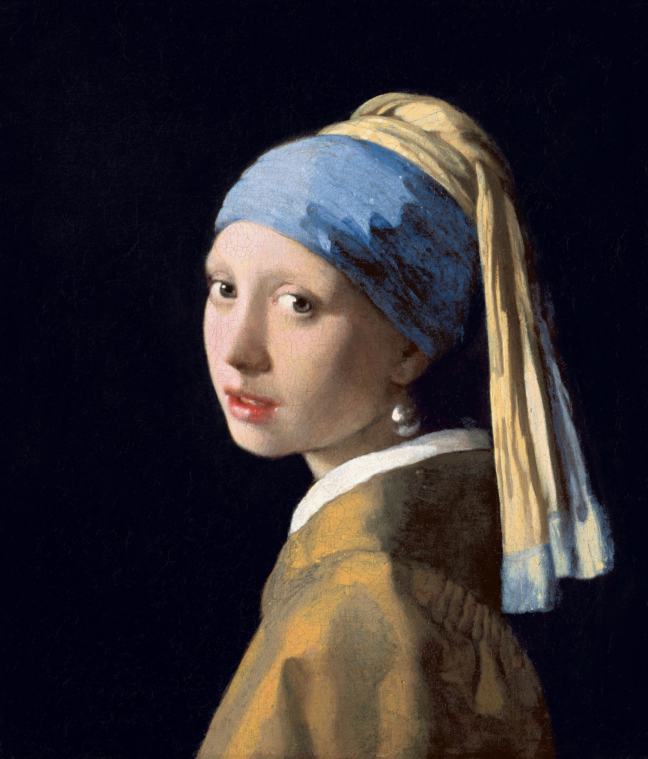

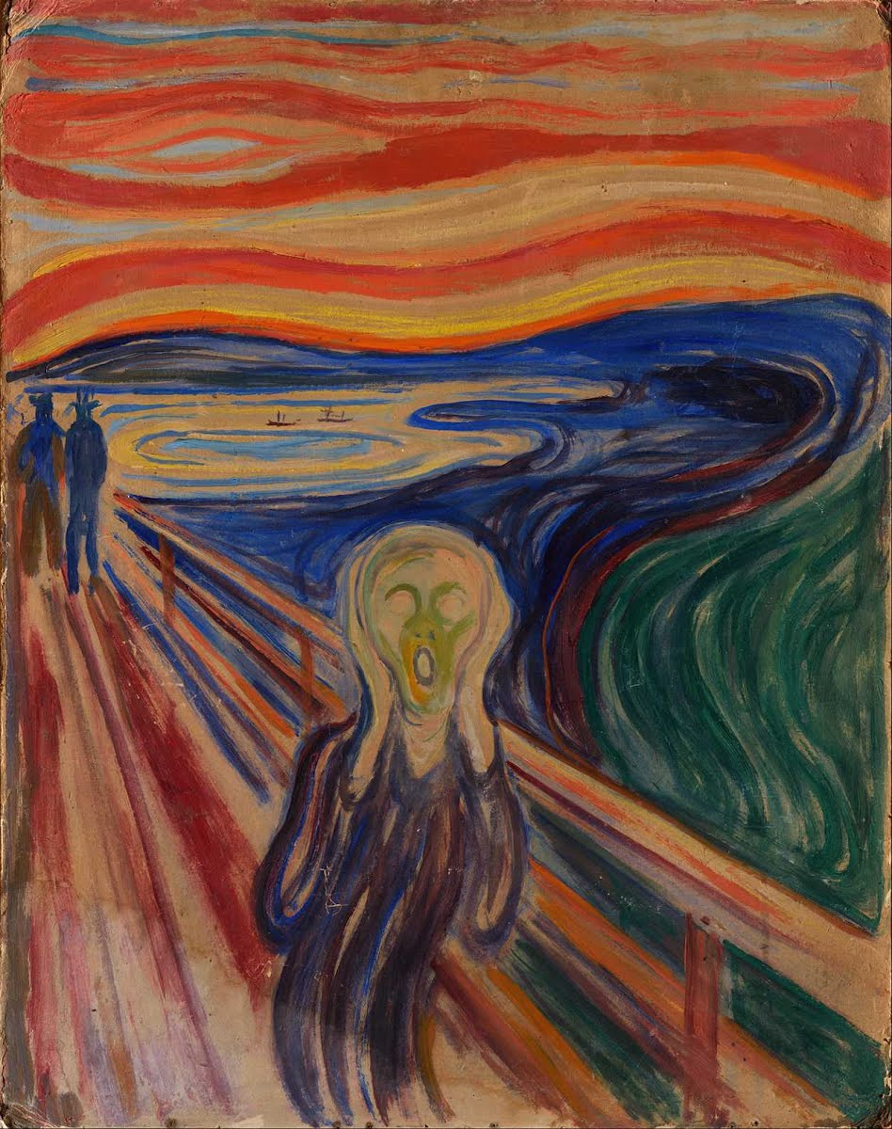

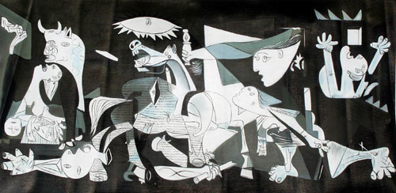

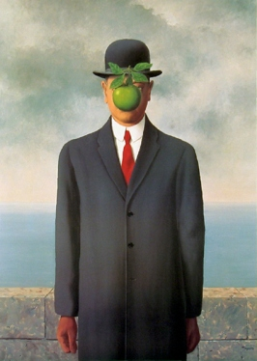

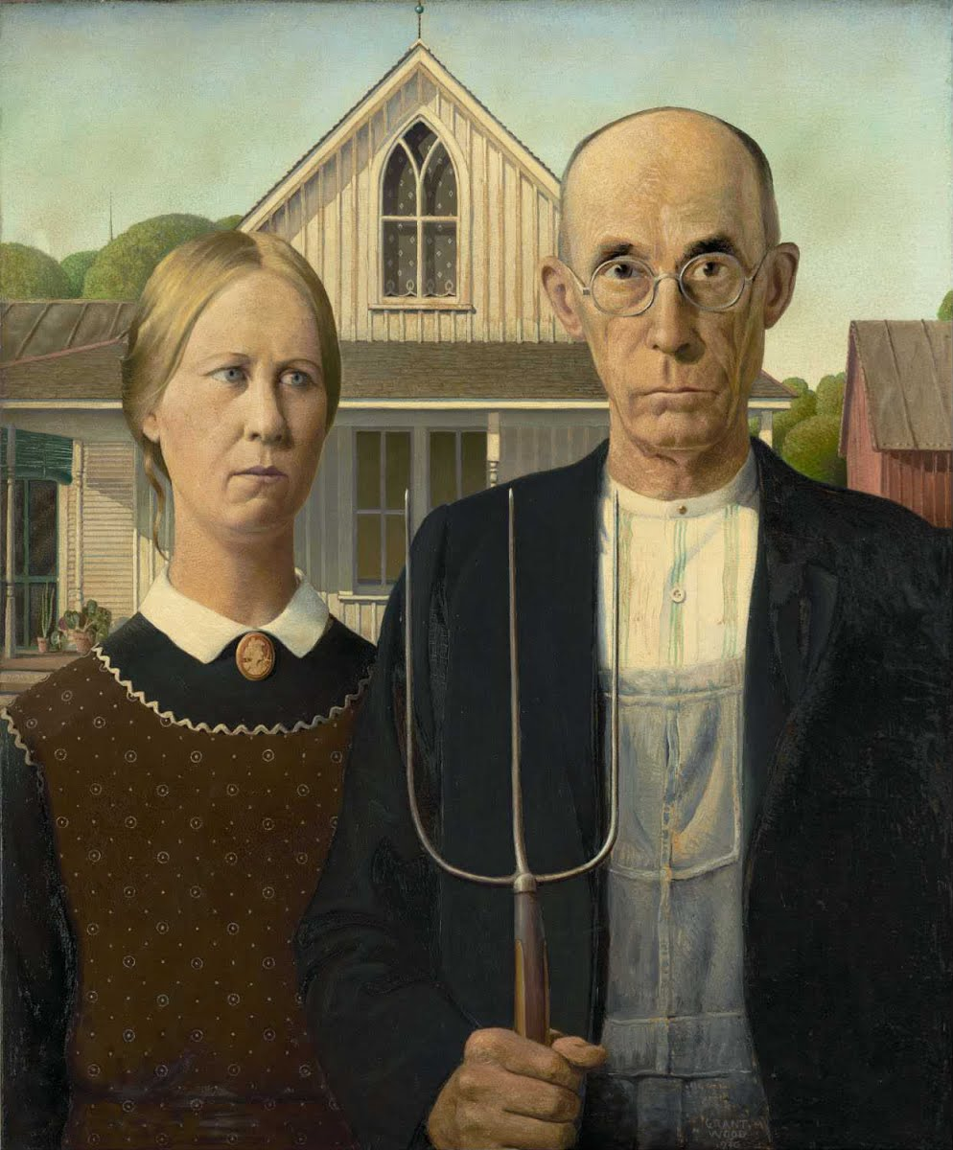
Notebook Check #9: Practice

