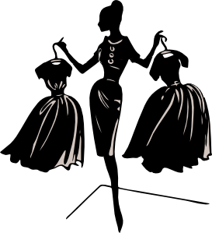
KEY  First and Last Name |  |  |  | Block
 |  | 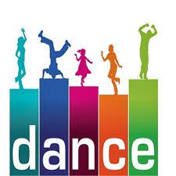
Points | Activity |  |  | Pages
 | - Music Anticipation Guide |  |  | 2
 | - Music Article |  |  | 3-5
 | - Music Vocabulary/ Elements /Principles |  |  | 6-8
 | - Music Critique |  |  | 9-11
 | - Dance Article |  |  | 12-13
 | - Dance Terms and Elements |  |  | 14
 | - Dance Critique |  |  | 15
 | - Fashion Article |  |  | 16-17
 | - Character and Fashion Creation |  |  | 18-19
 | - Going Fashion Crazy |  |  | 20
100  _ | - Score

Music Anticipation Guide

Answer the following questions to your best judgment.

- I believe/do not believe most professional musicians make a substantial amount of money.

- I believe/do not believe most professional musicians are born with the talent they have.

- I believe/do not believe most professional musicians spend the rest of their lives perfecting their craft.

- I believe/do not believe music is easy if you have the talent for it.

- I believe/do not believe most famous musicians do drugs or drink heavy amounts of alcohol.

- I believe/do not believe everyone dreams of being a rock star.

Make a list of your favorite songs below. Explain why they are your favorite.

Example:
- “Welcome to the Black Parade” by My Chemical Romance,
  - because... the music is powerful and uplifting despite the lyrics being about death.

  - because…

  - because…

  - because…

  - because…

  - because…

By looking at your list, would you say you are more of a lyrics (words) fan or a music (score) fan? Why?

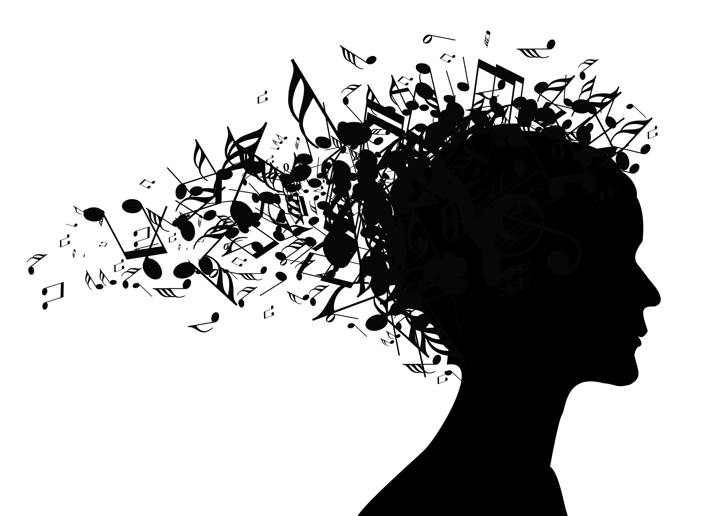
Music Article
Read, annotate, and answer the comprehension questions that follow.

10 Magical Effects Music Has On the Mind
By Dr. Jeremy Dean
Music can improve verbal IQ, aid in heart disease treatment, evoke colours in the mind and even help you see happy faces all around. Every fan of music knows the tremendous power it can have over both thoughts and emotions.
Great music can transform an ordinary day into something magical, even spiritual. It can provide solace, release, strong sensations and more.
But music’s influence spreads further still: right up from our genetic code, through our thoughts and bodies and out into how we relate in groups.
1. Improve verbal IQ
Practising the piano won’t just improve your musical abilities, it can also improve your visual and verbal skills.
A study of 8 to 11-year-olds found that, those who had extra-curricular music classes, developed higher verbal IQ, and visual abilities, in comparison to those with no musical training (Forgeard et al., 2008).
This shows the benefits of learning an instrument are not purely musical, but extend into cognition and visual perception.
2. Feeling the chills
Have you ever felt chills down your spine while listening to music? According to a study by Nusbaum and Silvia (2010), over 90% of us have.
How much you feel, though, depends on your personality. People who are high in one of the five personality dimensions called ‘openness to experience’, are likely to feel the most chills while listening to music.
In the study, people high in openness to experience were more likely to play a musical instrument, and more likely to rate music as important to them.

3. Active listening amps up happiness
If you’re not feeling the chills, perhaps you should try a little harder.
A recent study contradicts the old advice that actively trying to feel happier is useless. In research by Ferguson and Sheldon (2013), participants who listened to upbeat classical compositions by Aaron Copland, while actively trying to feel happier, felt their moods lift more than those who passively listened to the music.
This suggests that engaging with music, rather than allowing it to wash over us, gives the experience extra emotional power.

4. Singing together brings us together
Since music is often a social activity, making it together can help bring us together.
A study of almost one thousand Finnish pupils who took part in extended music classes, found they reported higher satisfaction at school in almost every area, even those not related to the music classes themselves (Eerola & Eerola, 2013)

Explaining the results, the lead researcher Päivi-Sisko Eerola, said:
“Singing in a choir and ensemble performance are popular activities at extended music classes. Other studies have established that people find it very satisfying to synchronize with one another. That increases affiliation within the group and may even make people like each other more than before.”

5. Music treats heart disease
…or at least it can help with the stress and anxiety associated with having treatment for coronary heart disease. A review of 23 studies covering almost 1,500 patients found that listening to music reduced heart rate, blood pressure and anxiety in heart disease patients (Bradt & Dileo, 2009).

6. Why sad music lifts you up
‘Mood management’ is the number one reason people love music.
And, all music fans know that music can have a cathartic effect. But, it’s still odd that, for some people, sad music can, under the right circumstances, improve their mood. Why?
According to a study by Kawakami et al. (2013), sad music is enjoyable because it creates an interesting mix of emotions; some negative, some positive. Crucially, we perceive the negative emotions in the music, but don’t feel them strongly.

7. Seeing happy faces
Music may make you feel different, but as little as 15 seconds of music can change the way you judge the emotions on other people’s faces as well.
A study by Logeswaran et al. (2009) found that a quick blast of happy music made participants perceive other’s faces as happier. The same was true for a snatch of sad music. The biggest effect was seen when people looked at faces with a neutral expression.
In other words: people projected the mood of the music they were listening to onto other people’s faces.

8. The colour of music
Music naturally makes people think of certain colours. Across different cultures, people pair particular types of music with particular colours.
In a study by Palmer et al. (2013), people from both Mexico and the US showed remarkable similarities in connecting duller, darker colours with sadder pieces of music and lighter, more vivid colours with happier music. A follow-up study showed that these music-to-colour associations were seen because of the emotional content of the music.

9. Could music bring back your vision?
In 60% of people who have a stroke, the visual areas of the brain are affected. This leads to ‘visual neglect': the patient loses awareness of objects on the opposite side to where the brain has been damaged. But, studies have found, when patients listen to their favourite music, some of their visual attention is restored (Tsai et al., 2013). So, music can be an important tool in rehabilitation for stroke patients.

10. Babies are born to dance!
Infants as young as five-months-old respond rhythmically to music and seem to find it more interesting than speech. In a study by Zentner and Eerola (2010), the babies spontaneously danced to all different types of music, and those that were most in time also smiled the most.
Maybe music really is in our genes!

Comprehension Questions:
- According to the text, what is one way to feel more connected to a piece of music?
  - Study music
  - Listen to mostly sad music
  - Allow music to simply wash over the listener
  - Actively listen by mentally trying to enjoy it

- What benefit results from students singing together in school?
  - Singing together in school promotes healthy competition between students resulting in better grades.
  - Singing together in school promotes unity and increases satisfaction with the school.
  - Singing together in school discourages gang behavior when the songs sung are positive in nature.
  - Singing together in school increases the chances that students can be “discovered” and become professional vocalists.

- According to the article, what personality factor makes someone more likely to play a musical instrument and enjoy music more?
  - Willing to try new things
  - Protective of people
  - Easily falls in love
  - Responsible

- Which of the following is NOT a benefit of listening to music?
  - Improves verbal skills
  - Improves cognitive skills
  - Promotes a positive attitude
  - Promotes expression

- Sad music promotes a positive attitude.
  - True b. False

- The texture of a song is strongly connected to vision.
  - True b. False

- Sad music reflects the true emotions of the listener, making them sadder.
  - True b. False

- What causes the mental connection between color and music?
  - Past experiences
  - Genetics
  - Emotional cues
  - IQ
- How is music important in rehabilitating stroke patients?
  - Music elevates stroke patients’ mood, which makes them easier to treat.
  - Music fixes the stroke patients’ white matter section of the brain, increasing IQ and reversing the effect of a stroke.
  - Music allows stroke patients to revert back a baby-like state and enjoy rhythm.
  - Music redevelops the stroke patients’ visual part of the brain.
- Which of the following verifies that this a quality source to use in a research paper.
  - The author is a verifiable doctor who explains the origins of his data.
  - The author explains the information in detail.
  - The author posts his data on a blog about psychology.
  - The author is a verifiable doctor who references all his own data.
Music Vocabulary
- ______________________ - to make sound “larger”
- ______________________ - to cause (something) to become more ______________ and lively.
- ______________________ - to give new ____________________ or energy to (something)
- _______________ - to move or cause (someone or something) to move after being __________
- ______________________ - to have an inward conviction of _________________________
- ______________________ - to cause (someone) to act in an angry, ____________________, or ______________________ way
- ______________________ - to ________________ (someone) to feel very _________________ and _________________________
- ______________________ - to spend time in quiet thought.
- ______________________ - to cause (someone) to be __________________, less angry, etc
- ______________________ - to come together to form or make (something)
Think of five more words that would help you express musical compositions:
- Music—the _________ of arranging sounds in time so as to produce a continuous and _________________ _________________ through melody, _________________, rhythm, and timbre. Also having the ability to bring a _________________, mood, or image to mind.
- ___________________ are the _________________ of a song.
- ___________________ is the music.
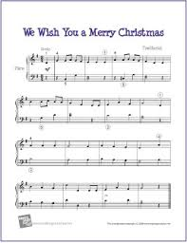
Elements of Music
Elements = core components; the ___________________________ that we use to build music
What are four elements of music?
Examples:
__________ note = ______beat
__________ note = ______ beats
__________ note = ______beats
Phrase = 4 _________________________
- Duration-_______________________________
______________________________________________________________

  - Beyonce’s “Halo” lasts 3 minutes and 45 seconds long or 3:45.
Examples:
___________________ - general feeling (ominous, _________, powerful, etc.)
___________________ - ___________________ behind the lyrics and score
___________________ - how ___________ the music is

- Intensity - _________________________
___________________________________
What effect does intensity have on the theme of a song?
___________________________________________________________________________________________________________________________
- Pitch - _____________________________________________________________________
How do pitch and intensity work together to create an overall sound?
________________________________________________________________________________________________________________________________________________________________________
- Timbre - the character or ________________ of a musical ___________ or voice as distinct from its ______________ and __________________.
  - In simple terms, ______________ is what makes a particular musical ____________ _______________ from another, even when they have the same ______________ and ____________. For instance, it is the difference between a guitar and a piano playing the same note at the same loudness.
- What is another name for timbre?
Why can’t Mrs. Teacher sound exactly like Nicki Minaj even when she matches her notes perfectly?_____________________________________________________________________________________________________________

Principles of Music
Principles = basic ________________ that determine__________________. Principles are what we create with the elements.
What are six principles of Music?
- Composition – The ______________________ or process of creating music.
  - The __________ _____________ of such an activity
- Form – shape or _____________________________ of something
  - The way that music is ______________________________
  - __________________ form occurs when a song starts at a low ________________ then builds to a _____________ intensity then settles for a low intensity at the end.
- Not every song is _______________. Not every song follows the same _______.
- Form is simply HOW THE SONG IS __________________.

- Genre – a certain type or category of ____________________________________
Examples:

- Harmony - ___ or more pitches/_______ played at the same time to create chords
- Rhythm – grouping of musical sounds by duration and ______________________
- Texture – the way something _________________; the ____________of music
Use your vocabulary words to describe the texture of the song.
Annotate the Lyrics

"Man in the Mirror"
by Michael Jackson

I'm Gonna Make A Change,
For Once In My Life
It's Gonna Feel Real Good,
Gonna Make A Difference
Gonna Make It Right . . .

As I, Turn Up The Collar On My
Favourite Winter Coat
This Wind Is Blowin' My Mind
I See The Kids In The Street,
With Not Enough To Eat
Who Am I, To Be Blind?
Pretending Not To See
Their Needs
A Summer's Disregard,
A Broken Bottle Top
And A One Man's Soul
They Follow Each Other On
The Wind Ya' Know
'Cause They Got Nowhere
To Go
That's Why I Want You To
Know

I'm Starting With The Man In
The Mirror
I'm Asking Him To Change
His Ways
And No Message Could Have
Been Any Clearer
If You Wanna Make The World
A Better Place
(If You Wanna Make The
World A Better Place)
Take A Look At Yourself, And
Then Make A Change
(Take A Look At Yourself, And
Then Make A Change)
(Na Na Na, Na Na Na, Na Na,
Na Nah)

I've Been A Victim Of A Selfish
Kind Of Love
It's Time That I Realize
That There Are Some With No
Home, Not A Nickel To Loan
Could It Be Really Me,
Pretending That They're Not
Alone?

A Widow Deeply Scarred,
Somebody's Broken Heart
And A Washed-Out Dream
(Washed-Out Dream)
They Follow The Pattern Of
The Wind, Ya' See
Cause They Got No Place
To Be
That's Why I'm Starting With

Music Criticism (4 steps)
Michel Jackson’s “Man in the Mirror”
https://www.youtube.com/watch?v=P5vz6iwV38U
Song Title: | Artist:
DESCRIPTION:  - Objectively describe the song’s story. What is the song about?  - Do not interpret or discuss the elements and principles of music at this stage | ANALYSIS:  - Analyze the composition, use the elements and principles to guide your looking  - Elements of Music: Duration, Intensity, Pitch, Timbre  - Principles of Music: Composition, Form, Genre, Harmony, Rhythm, Texture
Interpretation:  - What does the song mean? What is the artist trying to say?  - Describe the story, meaning, message, idea, mood, and/or feelings in the artwork.  - Historical and art historical relationships  - Opinions backed up by evidence from the score and lyrics. | EVALUATION:  - Your judgment about the music  - What is effective or ineffective in the work?  - What is the song’s value?  - Opinion supported by evidence in the artwork.

Critique of Music
Directions: After completing the four steps of art criticism, write a thorough critique of the work of art in paragraph form. Begin your critique by introducing the title, artist, and genre (TAG) of the piece and describe the music. In your description, analyze how the artist used the elements and principles. Give an interpretation of the piece followed by your evaluation to close your critique. (Hint- It helps to come up with a thesis statement formed from your interpretation then give evidence from the lyrics/score that support your thesis)
Connecting Music to Dance: Annotate and analyze the following quote.
“The dance can reveal everything mysterious that is hidden in music, and it has the additional merit of being human and palpable. Dancing is poetry with arms and legs.”
Charles Bauderlaire
Dance Article
Read, annotate, and answer the comprehension questions that follow.

The Many Health Benefits of Dancing
By Marjie Gilliam
Dayton Daily News Posted: 11/27/2012 12:01:00 AM MST

Besides exercise, dancing can help improve memory and cognitive function and makes people less likely to develop dementia.
Whether it's ballet or ballroom, clogging or jazz, dancing is a great way for people of all ages and physical abilities to get and stay in shape.
Simply put, dancing just doesn't feel like exercise. But the truth is, dance offers a total body workout, using all of the major muscle groups and providing heart-healthy benefits.
Along with keeping muscles toned, dancing burns body fat, increases balance and coordination and, because it is a weight-bearing exercise, strengthens bones, according to the AARP.
Just as muscles do during weight-bearing exercise, bones adapt to a weight load and the pull of muscles by building more bone cells, increasing strength and density and decreasing the risk of fractures, osteopenia and osteoporosis.
The benefits can extend beyond fitness.
A recent study in the Journal of Sports Science and Medicine found that teaching the cha-cha to a small group of older adults twice a week for six months was enough to improve their memory and cognitive function on a number of tests. Research published in the New England Journal of Medicine found that ballroom dancing at least twice a week made people less likely to develop dementia.
It also has been shown that some people with Alzheimer's disease are able to recall forgotten memories when they dance to music they used to know. Scientists know that exercise increases the level of brain chemicals that encourage nerve cells to grow. And dancing that requires you to remember certain steps and sequences boosts brain power by improving memory skills.
Participants in dance classes often find that the camaraderie and enjoyment they experience motivate them to continue staying active, thereby improving health longer term, the AARP finds.
Physical activity increases the rate at which antibodies flow through the blood stream, boosting immunity, according to the National Institutes of Health. The increased body temperature generated during moderate exercise can help prevent bacterial growth.
As in any form of exercise, regular dancing builds stamina and endurance, the ability of muscles to work hard for increasingly longer periods of time without fatigue. The more vigorous the type of dance, the greater the benefit.

Comprehension questions – answers may be in phrases.

- Aside from keeping muscles toned, what other things does dancing do?

- What credible source is cited in the article?

- Define “camaraderie” as used in the article.
- Define “stamina” as used in the article.

- Ballroom dancing at least twice a week made people less likely to develop what?

Answer each question in one or more complete sentences.

- What is meant by “a total body workout”referenced in the article?

- What is the connection between dance and Alzheimer’s disease?

- How does dance boost immunity?

Create a bibliographic entry/MLA citation of this article (use your reference book for help). Don’t forget the HANGING INDENT!

What do you believe the author’s intent/argument was with this article? Explain your reasoning; cite evidence from the text to back up your answer. TAG/ICE

Is dance a valid form of exercise? Defend your answer with specific evidence from the text. Be sure to use the proper TAG/ICE format.

Dance Terms and Elements
Define the following ACTION words.
- acrobatics - a _____________________________, showy, or startling performance or demonstration involving great __________________ or ______________________
- stretch - to become ________________ or wider when pulled; to ________________
- strain - to _________________ (as oneself) to the ________________
- twirl - to _________________ rapidly
- collapse - to suddenly lose _______________
- gravitate - to move _____________________ something
- leap - to ________________ free from or as if from the ______________________
- lock - a controlling _______________________
Terms to Know:
Movements - ___________________ made by the body
- _______________________________- actions of the body that cover ___________________ (walk, run, skip, hop, jump, _________________, leap, and ______________)
- __________________________________- Actions of the body that do ________cover space (bend, ______________________, twist, and swing)

Elements of Dance
- __________________- How fast or slow (_____________); even or uneven (_______________); and long or short (_________________) the movement is

- ____________________- The area covered by the dance movements (This includes shape, level, directions, and pathways.)
  - ___________________- Forward, __________________, sideways, up, down, etc.
  - ________________- The distance from the ______________
  - ___________________- Patterns that the body makes as it moves through ______________or on the floor
  - _____________- The design of the body as it exists in _____________
- ____________________- The use of energy while moving space.

Critique of Dance
Directions: Write a thorough critique of the work of art in paragraph form. (Hint- It helps to come up with a thesis statement formed from your interpretation then give evidence from the lyrics/score that support your thesis)

Fashion Article
Read, annotate, and answer the comprehension questions that follow.
Confidence Dressing: How Clothing Affects the Mind
APRIL 27, 2012
by KATHERINE BERNARD
Great news. Science is one breakthrough closer to understanding the brain chemistry behind your intense interest in clothes, and as it turns out, your outfit may alter how you approach and interact with the world. In preliminary findings from a study published on the Journal of Experimental Social Psychology’s website, subjects who donned white coats that they thought belonged to doctors performed better on tests than those who wore street clothes, or those who thought the coats were associated with artists. Their heightened focus was evident only when subjects actually put on the coat in question (not merely when they were in the same room). It’s no secret that assembling an outfit is like selecting social armor, and that what we wear has power over others (if there weren’t truth to the cliché “lady in red,” designers wouldn’t be making so many scarlet dresses), but this study shows if you have a strong cultural association with a garment, wearing it can affect your cognitive processes. This phenomenon is called enclothed cognition, meaning that if your brain links Miuccia Prada’s or Phoebe Philo’s collections with powerful, intelligent women, you’re likely to take on those attributes when you wear that Prada pleated skirt or Céline jacket.
To explore this theory, Vogue asked several women—in careers ranging from art to e-commerce to politics—what pieces in their closets helped them bring their A-game to work. Though none had appropriated Hillary Clinton’s famed pantsuits, some veered towards popular icons that assert command (“A power outfit for me always begins with a great pair of heels,” says Gabriela Palmieri, senior vice president at Sotheby’s in New York), while others cited correlations between brands and confidence. Lauren Santo Domingo made careful selections when raising funds to launch Moda Operandi, where she is a cofounder and creative director. “We were meeting the best investment funds around the world and I felt that they would take one look at my Peter Pilotto techno print shift with my ironically mismatched Charlotte Olympia clutch and immediately know that I barely broke 500 on my Math SATs,” Santo Domingo says. “I quickly shuffled around my wardrobe and relied on Céline with sprinklings of Acne to get me through these intense meetings without letting my true eclectic fashion roots betray me.” In time, Santo Domingo says she felt strong showcasing her personal style, and eventually saw it as an asset. Model and psychology student Julia Frakes always gravitates toward Prada for interviews, and has a go-to brand for test taking: “I wore Marni when I took my Wechsler exam [designed to measure adult intelligence]. I swear Marni increases one’s self-perceived intelligence levels.” Suffice it to say, Frakes scored a high performance IQ.
So, tell the skeptics: Your closet isn’t frivolous, it contains a myriad of channels to heightened performance, a selection of gateways to the best versions of yourself. As Jonathan Lethem said in his novel You Don’t Love Me Yet: “You can’t be deep without a surface.”
- What does the term “enclothed cognition” mean?
- The process of mentally preparing the brain for a thinking task.
- The process of thinking critically about what a person will wear.
- The process of thinking like the kind of person who wears the clothes that the thinker is currently wearing.

- According to the article, what would be the best outfit for a woman interviewing at a prominent business firm?
- Khaki pants and a nice dress shirt with flats and modest jewelry.
- Expensive pants with a matching jacket, silk shirt, fine name-brand heels, and classy jewelry.
- Loose-fitting, patterned dress with chunky jewelry, wedge shoes, and flower headband.
- An outfit that makes the interviewee feel confident so she can perceive herself as formidable.

- Explain the quote “You can’t be deep without a surface.”
- How people are seen on the outside affects how people feel about deeper things on the inside.
- Water tension relates to the bonding between molecules of water at the surface of a liquid.
- How people look on the outside is more important than how thoughtful they are on the inside.
- People who wear “prep” clothes are smarter than those who wear bohemian clothes.

Character Creation
Objective: Students will be able to create fashion based on character references.
Directions:
Answer the following questions about a character that you make up. This character should be older than you, maybe the person you hope to be one day.
Name: Age:  Job:  Earns how much money?  Dreams of one day … | Where does your character live?  Is this a city or town?  Describe the area
What do his/her friends think of him/her? | Is your character in a relationship? What does he/she think about the relationship?
What makes your character truly happy? | What is your character’s major character flaw? What does should the character need to work on in order to be more successful?

Fashion Creation
Fashion is reflective of an individual’s life. Design a series of complete outfits for your model. Use research from the internet to maintain authenticity.
Describe the pieces of the outfit below:

Male |  | Female
Going to Work

What does your model wear to work? If he/she is a homemaker, what does he/she wear when being a homemaker? If he/she is a student, what does she wear to school?

Fun Night Out

Describe what your model does to have fun with friends.

Going on a Date
How does your model dress when going on a date?

Going Fashion Crazy
Annotate and analyze the following quote.

“Fashion is not something that exists in dresses only. Fashion is in the sky, in the street, fashion has to do with ideas, the way we live, what is happening.” Coco Chanel

Directions: Create an over-the-top, Lady Gaga fashion for your model! Have fun and be CREATIVE! Circle a theme from the following choices.

Ocean Livestock Technology Luxury Items Coal

Agriculture Forestry Military Beach Jungle

