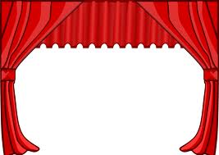

SHAKESPEARE’S LIFE AND TIMES MINI-NOTEBOOK CHECK
Name ____________________________
Test scheduled for_________________

2.

3.

4.

5.

Notebook Check 1: Who is Shakespeare?

Shakespeare wrote during the ______________________ period known as the ______________________ Era, named after _________________________. This time period was known as a time of immense creativity, culture and the arts.

1564 Shakespeare was born in England around (date) ________________ in __________________ (place).
He attended the ____________________ where he studied about 10 hours/day, 6 days/week.
1582 He married _______________, a woman eight years older than him; Together they have ____
children; one later dies.
1589 He sets out for ______________ to make his fortune. He writes his first plays: Richard the Third,
The Comedy of Errors, Titus Andronicus, The Taming of the Shrew, Henry the Sixth Parts I, II and III.
1592 He not only becomes a playwright but an __________ as well; theaters close down for two years because of the ____________. He uses this time to write two _______________________: Venus & Adonis and The Rape of Lucrece
1594 Theaters reopen; he completes Love’s Labour’s Lost, Romeo & Juliet, Richard the Second and King John. He becomes a charter member of _______________________________________________.
1596 He writes his ___________ between now and 1603; also writes The Merchant of Venice; Henry the
Fifth, Julius Caesar, and Twelfth Night.
1603 Queen Elizabeth dies and __________________________ becomes England’s new ruler King James renames Lord Chamberlain’s Men to ___________________________. Between now and 1608, he writes the tragedies Othello, King Lear, Macbeth, and Antony & Cleopatra.
1608 Shakespeare writes his last plays, A Winter’s Tale and The Tempest. Decides to retire and move back to __________________.
1616 Shakespeare dies on April 23rd at the age of 52.
1623 His _______________________ was published by two members of the King’s Men.

Shakespeare has written ___________________ plays, as well as many sonnets and poems.

Notebook Check 2:
Elizabethan drama

1-) There are three important aspects of Elizabethan Drama that make it differ greatly from the drama of today:
a-)
b-)
c-)

2-) The Importance of Words:
a-) Shakespeare’s plays are primarily ____________, not visual.
b-) Shakespeare used words to express the ____________ and ____________of his dramas.
c-) Today’s dramas are mostly ___________.

3-) Real Life vs. Stage Life:
a-) Characters in a play are understood to be ________________ real people, not real people.
b-) Modern dramas suggest that everything is ____________, especially the place and the people.

4-) Symbolic Art:
a-) Shakespeare was influenced by ______________ because this type of art was deeply _____________.
b-) This art focused on universals by presenting them through particulars. For example:
- a universal ____________________ its particular ____________________
- a universal ____________________ its particular ____________________
- other universals include

6-) Three ways to analyze characters in a Shakespeare play are:
a-)
b-)
c-)

7-) Modern-day theatrical companies often change Shakespeare’s dramas by interpreting them differently or just updating them. These can be done by:
a-)
b-)

8-) During this time, all actors were __________ because it wasn’t proper for _________ to be on stage.

9-) Were actors well-respected by others?
Notebook Check 3: Elizabethan Beliefs
Religion:
- How were people in Elizabethan England different from people today in regards to religion?

- What was the reformation?

  - How did it affect Europe during the renaissance period?

- Who were the puritans?

  - What did they want to do?

  - Why?
The Chain of Being:
- What was The Chain of being?

  - List the hierarchy of persons on The Chain of Being.

  - What would happen to those who accepted this belief?

  - What would happen to those who denied it?
Myths and magic:
- What formed part of the Elizabethan view of life?

  - How important were these things to Elizabethans?

- What did Elizabethans think that fairies, goblins and sprites came out to do? Give examples.

  - What holiday today do these Elizabethan beliefs remind you of?

- What were often blamed on witches?

  - Who were the witches?

- What is astrology?

  - Why was it more important than it is today?

  - In what ways do magazines, newspapers and the internet still promote astrology as a means to explain life in general?
Personal Connection: The Zodiac and You

What is your astrological (zodiac) sign?___________________________________________
Which three traits do you think are TRUE about you? List and provide reasons for each

Which three traits do you think are FALSE about you? List and provide reasons for each?

Which character traits contribute to your DECISION MAKING ABILITY? Use examples of your character traits and situations you have experienced making decisions.

Which character traits contribute to your PERSONAL RELATIONSHIPS? Use examples of your character traits and situations you have experienced with relationships.

Little and large:
- What was the human body thought to represent?

  - How were they linked?

  - Explain the relationship.

- What was the human body thought to contain?

  - What affect did these things have on the human body? Be specific.

Notebook Check 4: Drama TERMINOLOGY

Use you’re the literary handbook of your textbook or a dictionary to match the following.

Drama
Comedy
Tragedy
Playwright
Producer
Director
Cast
Act
Scene
Script
Cue
Plot
Exposition
Stage Directions
Dialogue
Monologue
Soliloquy
Setting
Characterization
Props

A-) a unique form of literature that is identified by the distinct appearance of a script, with its stage directions, character parts
and division into acts

B-) Writer of plays

C-) Raises money for the production, locates sponsors, and hires the actors, actresses, director and technicians

D-) Achieved mostly through italicized words; indicates and describes time, place, and general environment of the play; describes scenery, props and floor plan; introduces characters as play opens; establishes tones and places audience into a mood

E-) Achieved primarily through dialogue; achieved through the character’s actions, opinions of that character by others, what the character says, and what the character looks like

F-) lines spoken by the characters; assists in allowing plot and action to unfold on stage as characters interact

G-) an extended speech made by one person

H-) A monologue in which a character expresses private thoughts while alone on the stage

I-) Sequence of events which involves character and conflict

J-) Achieved through dialogue; explains “how it all began” or what happened before the time covered in the play; indicates what the character is like and what situation has risen that creates the problem that must be solved

K-) Notes to describe how the play is to be staged or performed; achieved through italicized words; gives actors/actresses directions like movement, tone of voice/voice inflection, and feelings and emotions; helps with visualization when reading

L-) A drama that includes conflicts designed to amuse or entertain without arousing deep emotional feelings; usually results result in a happy ending

M-) A drama that deals with a serious subject involving persons of significance; audience feels both pity and fear

N-) A signal before or during a stage performance to prompt a person to action

O-) Stage properties used to enhance the reality of a dramatic performance

P-) A major division of a play

Q-) Part of a play presenting one episode; division of acts

R-) The written material of a dramatic presentation

S-) Interprets the drama; one who manages or guides a production; brings together lighting, sound, acting and staging for final production

T-) Actors and actresses in a play

Notebook Check 5: If Shakespeare Wrote Pop Songs-He’s So Fancy

Use your Shakespearean Words bookmarks to help you translate these current pop songs into modern language. You may work with a partner.

Paraphrasing is _____________________________________________________________________________________________________________________________________________________________________________________________________________________________________________________________________________________________________________________________________________________________________

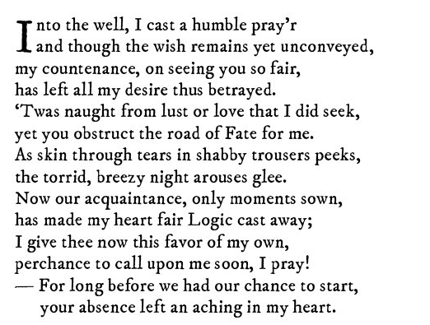
Paraphrase:__________________________________________________________________________________________________________________________________________________________________________________________________________________________________________________________________________________________________________________________________________________________________________________________________________________________________________________________________________________________________________________________
What song am I?
___________________________________________

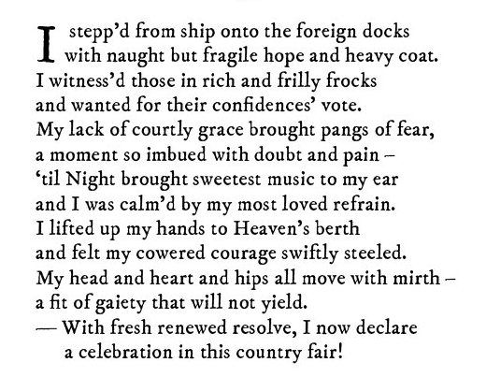
Paraphrase:___________________________________________________________________________________________________________________________________________________________________________________________________________________________________________________________________________________________________________________________________________________________________________________________________________________________________________________________________________________________________________________________

What song am I?
___________________________________________

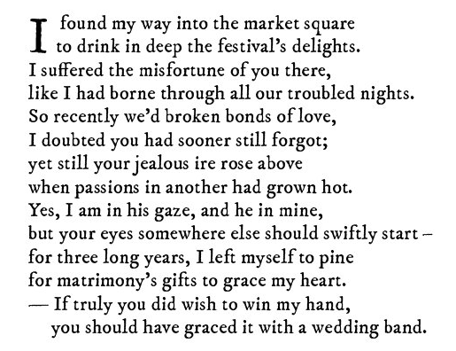
Paraphrase:________________________________________________________________________________________________________________________________________________________________________________________________________________________________________________________________________________________________________________________________________________________________________________________________________________________________________________________________________________________________________________

What song am I?
______________________________________________

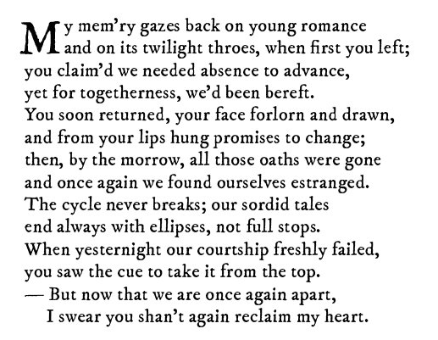
Paraphrase:___________________________________________________________________________________________________________________________________________________________________________________________________________________________________________________________________________________________________________________________________________________________________________________________________________________________________What song am I? _______________________________________

RESPONDING TO VISUALS
- Choose one picture from the Daily Life in Elizabethan England.
- After describing the picture briefly, write a response to the picture of your choice using the following prompt/s.
- What about this image stands out to you?
- Why do you think I chose this image?
- What do you think is happening in the image?
- What event or topic do you think these images are related to?
- What is the first thought that comes to mind when you see this?
- What does this image remind you of?
- How do you think the people in image feel?
- What do you think a snapshot of what happened immediately after this would look like?

